

For immediate release
To: All media
09 August 2025

JOHANNESBURG CITY LIBRARY REOPENS AFTER MAJOR UPGRADES – CELEBRATING 90 YEARS OF KNOWLEDGE AND CULTURE

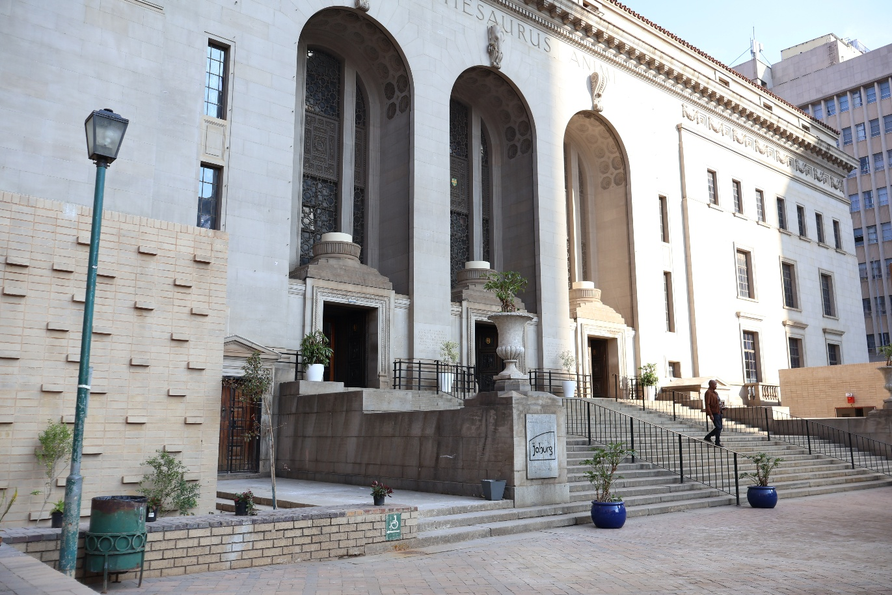

The iconic Johannesburg City Library has officially reopened its doors to the public after an extensive upgrade led by the Johannesburg Development Agency (JDA). The reopening ceremony, held on Saturday, 09 August 2025, was officiated by Executive Mayor, Cllr Dada Morero, with MMC for Development Planning, Cllr Eunice Mgcina, and JDA CEO, Mr Themba Mathibe in attendance.

This year’s reopening marks a significant milestone – the 90th anniversary of the library, which first opened on 6 August 1935. Known for its Italian-inspired architecture, the building remains one of the City’s most treasured cultural landmarks and a vital hub for learning, research, and community engagement.
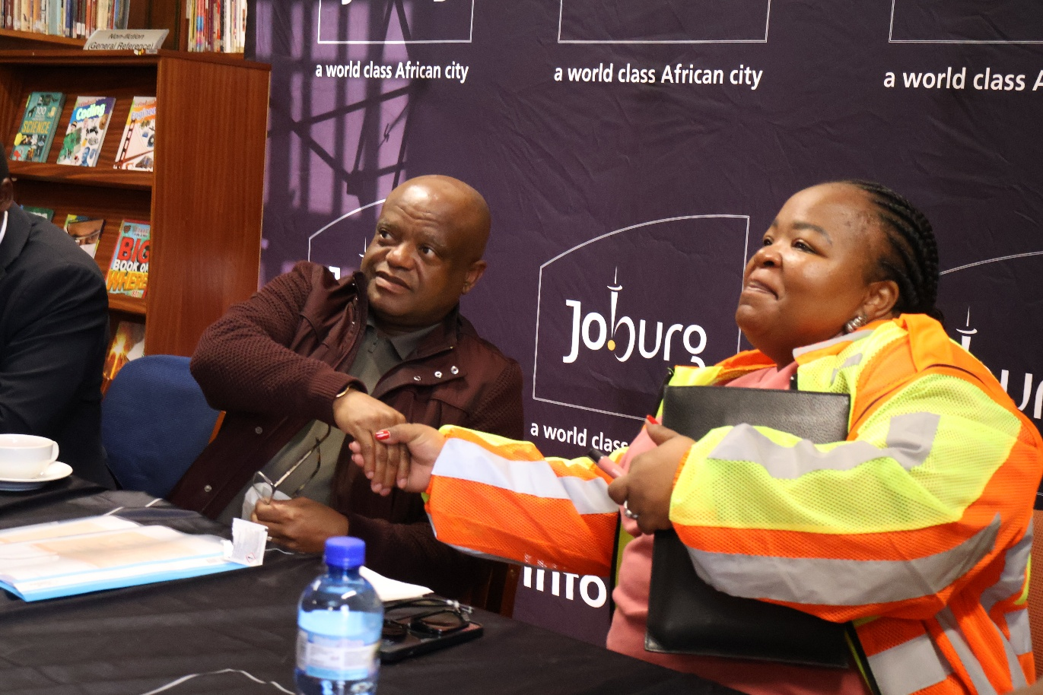

Development Interventions by the JDA

As the implementing agent, the JDA undertook significant refurbishment and modernisation works to preserve the library’s historic features while improving accessibility, safety, and functionality. These interventions included:

- Structural repairs and heritage restoration.
- Upgraded electrical, IT, and security systems.
- Installation of modern heating, ventilation, and air conditioning (HVAC) systems.
- Enhanced accessibility features for persons with disabilities.
- Interior refurbishments to reading rooms, study spaces, and archival storage areas.

These improvements have transformed the Johannesburg City Library into a flagship example of the JDA’s approach to working with stakeholders to enhance urban areas, address local challenges, and meet community needs in a sustainable way. The project drew on local knowledge of the development context, ensuring co-produced solutions that cultivate ownership, civic pride, and citizenship.

Recognition on the Global Stage

The Presidential Joburg Working Group has recognised the Johannesburg City Library as part of Workstream 7 of the G20 Initiative – a programme aimed at boosting tourism and preserving libraries as essential cultural heritage sites. This recognition underscores the library’s importance not just to Johannesburg, but also as a heritage asset of international significance.

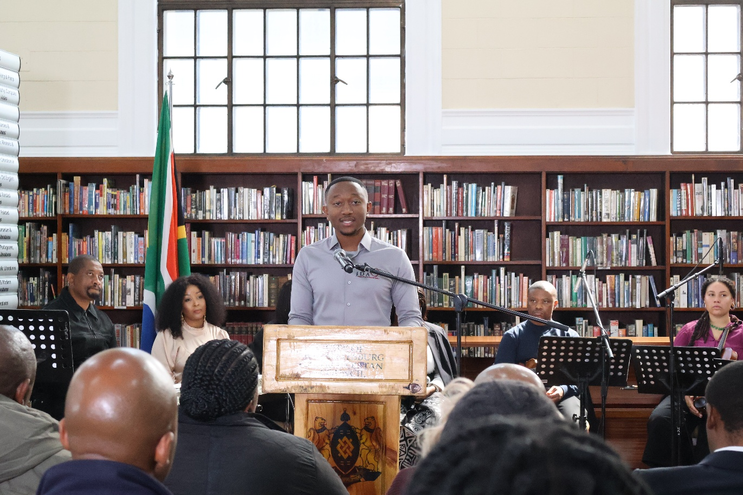

MMC for Development Planning, Cllr Eunice Mgcina, said, “The reopening of the Johannesburg City Library serves as a restoration of a space for knowledge, inspiration, and community connection. As we celebrate its 90-year history, we also reaffirm our commitment to making knowledge accessible to all residents of Johannesburg.”

JDA CEO, Mr Themba Mathibe, added, “This project is a testament to how the JDA works with partners and communities to deliver developments that are both functional and culturally significant. By blending heritage preservation with modern infrastructure, we have ensured that this landmark will continue to serve generations to come.”

The Johannesburg City Library houses over 1.5 million books and serves more than 250,000 members, making it one of Africa’s largest and most valued public knowledge resources. Its reopening will reignite its role as a centre for learning, cultural enrichment, and tourism in the City of Johannesburg.

ENDS

Issued by: Kenneth Nxumalo
Johannesburg Development Agency

For more information:
Elias Nkabinde
Email: enkabinde@jda.org.za
Phone: 076 961 8022
Website: www.jda.org.za

Johannesburg City Library Reopens on Women’s Day, Celebrating 90 Years of Knowledge

