

For immediate release
To: All media
03 November 2025

BUILDING A CITY WITHOUT BARRIERS: JOBURG’S UNIVERSAL DESIGN APPROACH DURING DISABILITY RIGHTS AWARENESS

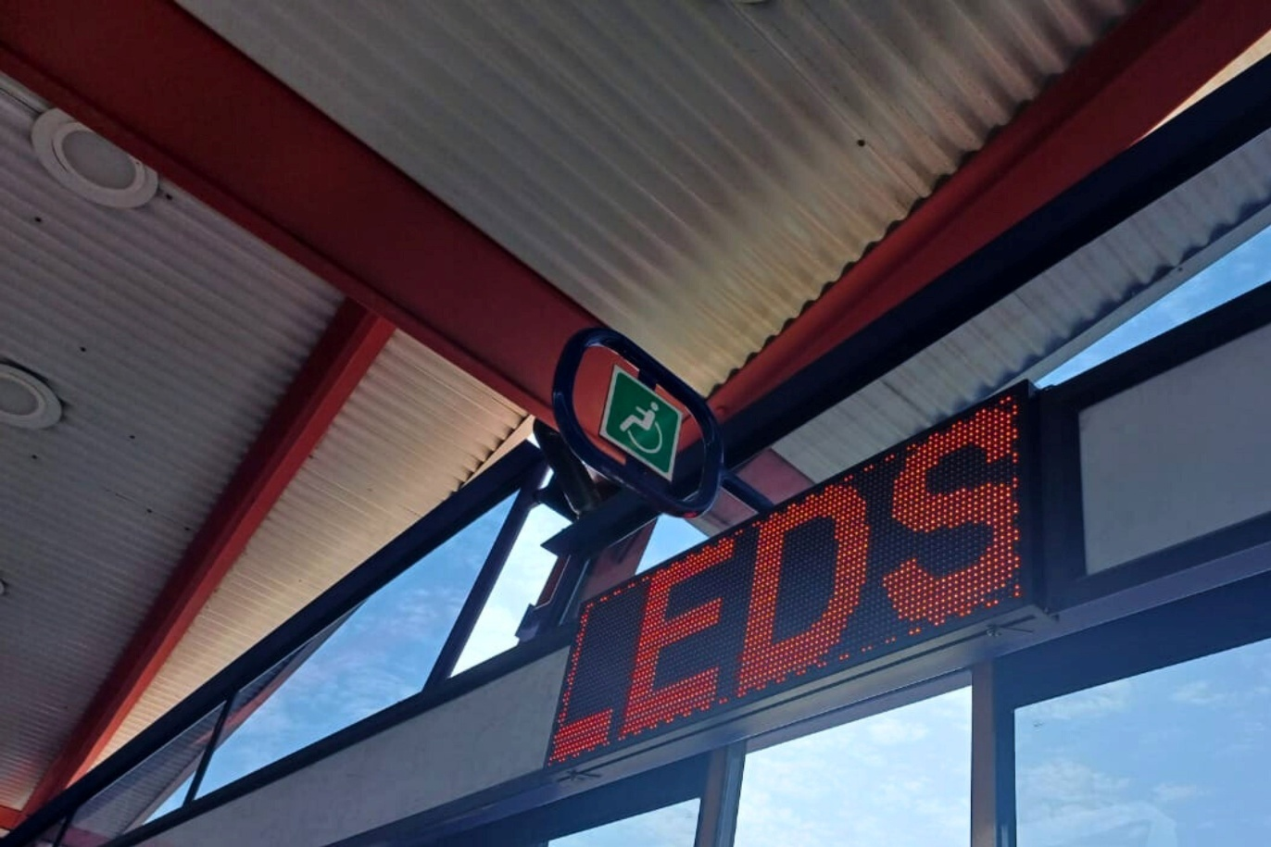

Every journey through Johannesburg should be one that everyone can take — confidently, independently, and safely. Yet for many people with disabilities, everyday travel remains a challenge.

As South Africa marks Disability Rights Awareness Month (DRAM) from 3 November to 3 December, the Johannesburg Development Agency (JDA) reaffirms its commitment to building a truly inclusive city through the rollout of the Universal Design Access Plan (UDAP).

Implemented on behalf of the City of Johannesburg’s Transport Department, the UDAP runs from January 2025 to June 2026. It aims to ensure that every aspect of public transport — from signage and stations to vehicles and digital platforms — meets the needs of all users, including persons with disabilities, older adults, and parents with young children.

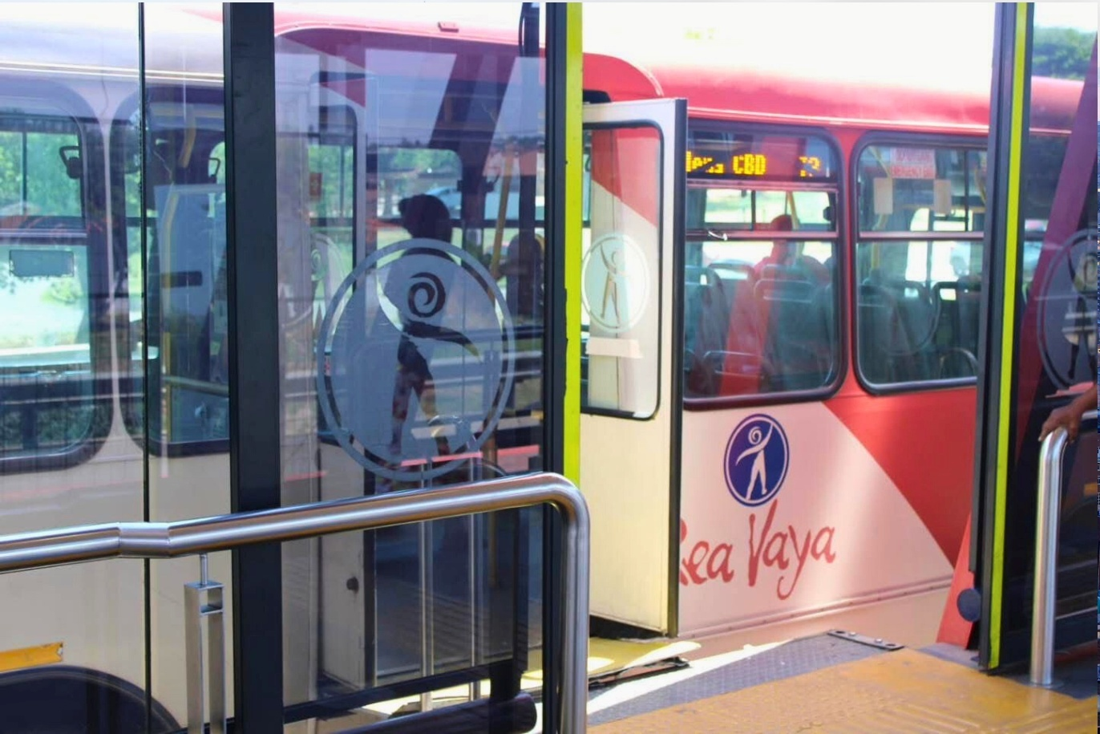

“Universal design is about shaping our city’s public transport systems so that everyone can participate fully in economic, social, and cultural life. Accessibility must be built in — not added on,” says JDA CEO Mr. Themba Mathibe.

The plan will assess and guide improvements to Rea Vaya, Metrobus, and Putco services, focusing on practical changes that make movement through the city equitable and barrier-free.

It will also align Johannesburg’s transport systems with the South African Constitution and national transport legislation, reinforcing the principle that mobility is a fundamental right.

Through initiatives like the UDAP, the JDA continues to champion the integration of universal design principles in infrastructure planning and implementation — ensuring that development promotes independence, dignity, and inclusion.

This DRAM, the JDA celebrates the resilience and contribution of persons with disabilities while calling for collective action to make Johannesburg a city that works for all, where accessibility is the standard — not the exception.

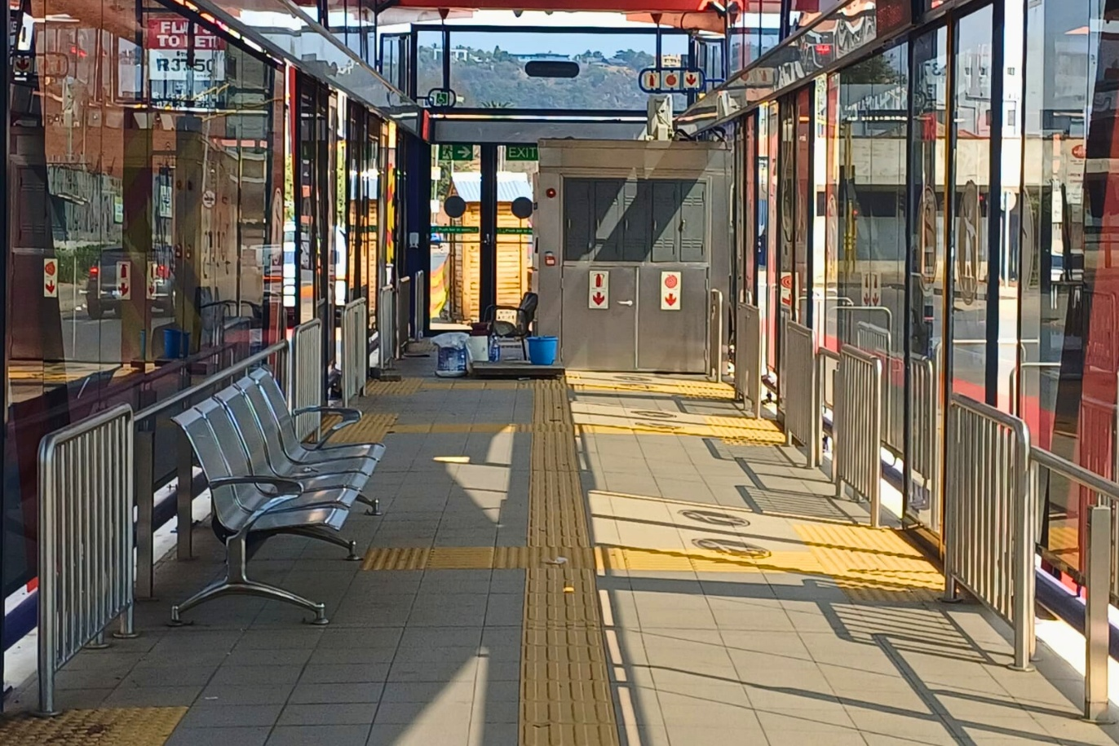

ENDS

Issued by: Kenneth Nxumalo
Johannesburg Development Agency

For more information:
Elias Nkabinde Email: enkabinde@jda.org.za
Phone: 076 961 8022
Website: www.jda.org.za

JDA launches Universal Design Access Plan to improve public transport accessibility in Johannesburg

