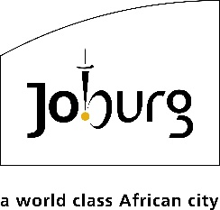

For immediate release
To: All media
02 December 2025

NYDA AND JDA SIGN STRATEGIC MOU TO ACCELERATE YOUTH ECONOMIC PARTICIPATION AND INCLUSIVE URBAN DEVELOPMENT

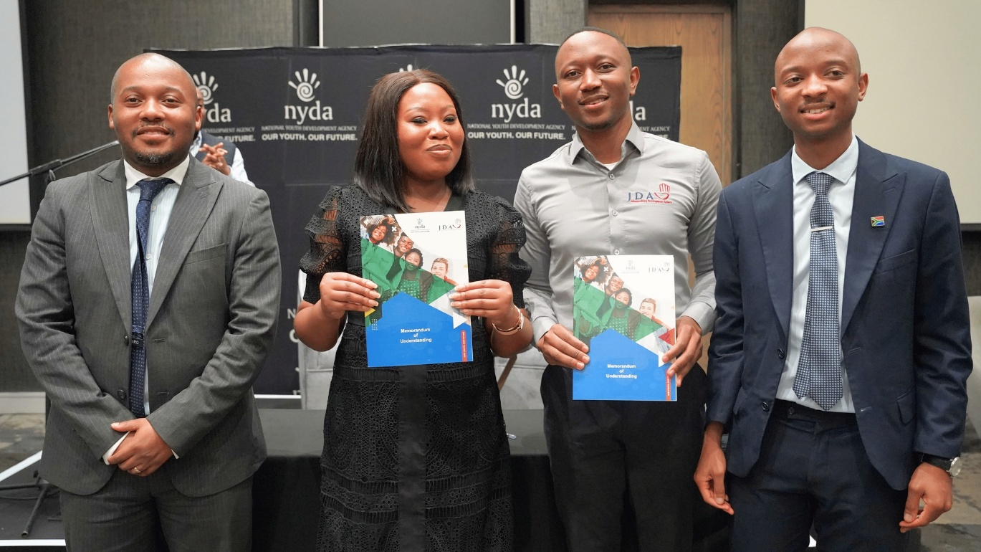

The Johannesburg Development Agency (JDA) has signed a Memorandum of Understanding (MoU) with the National Youth Development Agency (NYDA), marking the start of a strategic partnership to advance youth economic participation, enterprise development, and inclusive urban growth across the City of Johannesburg.

The MoU was signed during the NYDA’s 100 Days Stakeholder Engagement at The Capital on the Park. This agreement reflects a shared commitment to creating meaningful pathways for young people to access opportunities, skills, and support within the city’s development landscape.

Key areas of collaboration include:

- Youth development and employment: Skills programmes, short-term placement opportunities, and participation in JDA construction and infrastructure projects.
- Enterprise development and innovation: Support for youth-owned businesses, entrepreneurship competitions, and development of funding frameworks.
- Education and outreach: Accessible platforms for youth to receive information, guidance, and support, with JDA providing venues and programme coordination.
- Construction and infrastructure empowerment: Compliance training, mentorship for young women and persons with disabilities, and greater youth participation in the built environment sector.
- Communication, governance, and coordination: Information sharing, joint steering committees, and aligned implementation of development initiatives.

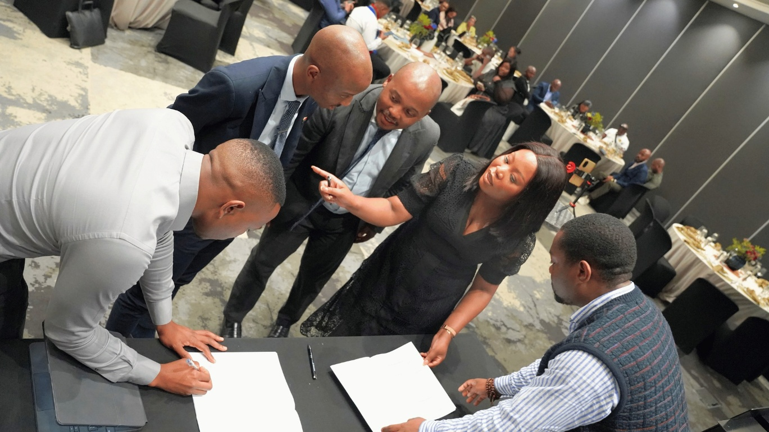

Speaking at the signing ceremony, JDA CEO Mr Themba Mathibe emphasized the significance of the partnership:

“Today marks a significant moment as we formalize our partnership through this Memorandum of Understanding. This collaboration will create pathways for youth empowerment, entrepreneurship, and innovation in Johannesburg. Our city thrives when its young people thrive. Together, we aim to unlock opportunities that will shape the future of our economy and communities”, he said.

The MoU will be implemented over a three-year period, guided by a joint project steering committee and a detailed implementation plan to be finalised within 60 days.

ENDS

Issued by: Kenneth Nxumalo
Johannesburg Development Agency
For more information:
Elias Nkabinde Email: enkabinde@jda.org.za
Phone: 076 961 8022
Website: www.jda.org.za
City of Joburg’s development project ignites generation of young changemakers

JDA creates empowering spaces for youth

