

For immediate release
To: All media
03 December 2025

REIMAGINING JOHANNESBURG’S HIGH COURT PRECINCT
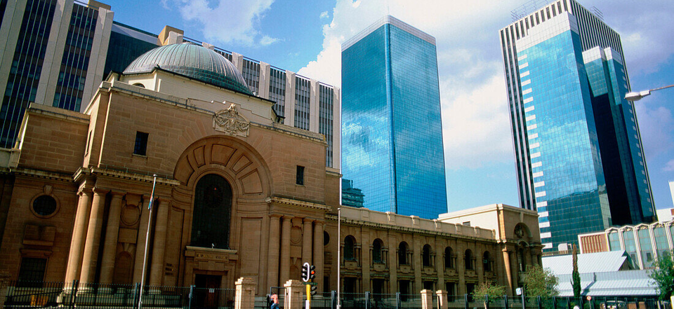

The Johannesburg Development Agency (JDA), on behalf of the City of Johannesburg, has commenced implementation of the High Court Precinct Public Environment Upgrade (PEU) Project — an initiative aimed at transforming the public environment surrounding the Johannesburg High Court into a safe, accessible, and vibrant urban precinct.

The project focuses on the area surrounding the Gauteng Local Division of the High Court, located within Johannesburg’s Central Business District (CBD). This precinct is bounded by Lillian Ngoyi Street (north), Delvers Street (east), Helen Joseph Street (south), and Eloff Street (west).

Currently characterised by mixed-use activities including commercial, residential, retail, and informal trading, the precinct also features key public amenities such as toilets and street furniture.

The upgrade seeks to elevate this vital civic node to reflect the dignity, functionality, and accessibility expected of a judicial precinct within a modern African metropolis.

The 2023 Review of the High Court Precinct Plan reimagined the area’s vision in alignment with the City’s broader urban development framework, setting out to:

- Improve safety and walkability in the precinct;
- Promote economic growth and investment;
- Strengthen urban management;
- Foster partnerships among public and private stakeholders;
- Enhance attractiveness, cleanliness, and usability of public spaces; and
- Facilitate local and foreign investment while promoting area businesses.

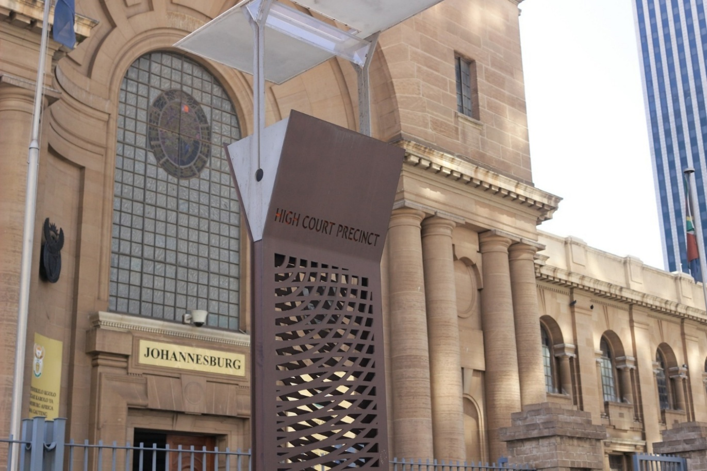

Scope and Progress

The High Court Precinct PEU includes comprehensive planning, design, stakeholder consultation, and construction supervision. The JDA’s scope of work covers:

- Reviewing concept and preliminary designs for key properties;
- Securing necessary development approvals;
- Engaging key stakeholders;
- Preparing detailed designs of approved plans;
- Supervising construction works on-site;
- Implementing urban management initiatives; and
- Project close-out and monitoring.

The project has completed Stage 1 (Inception and Planning), while Stage 2 (Concept and Preliminary Design) is 95% complete, pending final approval from relevant authorities. Stage 3, focusing on detailed design and refinement, is currently underway. Stakeholder engagement remains ongoing to ensure alignment with the needs of residents, businesses, and city departments.

Design and Infrastructure Enhancements

Key design interventions will include:

- Identification and reorganisation of parking, drive-in access, and drop-off areas;
- Upgrading street furniture and urban materials;
- Introducing new walkways, benches, recycling bins, trees, and landscaping;
- Extending kerb lines and installing bollards to improve pedestrian safety;
- Integrating Universal Access features at all intersections; and
- Proposing pedestrianisation of a section of Pritchard Street (between Von Weilligh and Van Brandis Streets), with Kruis Street redesigned as a one-way route travelling south toward Helen Joseph Street.

Driving the Inner-City Regeneration Vision

Speaking on the importance of the project, Mr Eric Raboshakga, the Executive Director for Development Planning said, “The High Court Precinct Public Environment Upgrade is a key component of Johannesburg’s broader inner-city regeneration agenda”.

“By improving safety, accessibility, and urban management, this project reinforces the City’s commitment to creating inclusive, vibrant, and investor-friendly spaces,” he said.

Mr. Themba Mathibe, Chief Executive Officer of the Johannesburg Development Agency said, “The JDA continues to transform strategic precincts like this one into areas that are not only functional but also reflective of JDA’s emphasis on resilient, sustainable and liveable urban areas in identified transit nodes and corridors, he said.”

“The JDA’s work within the High Court Precinct aligns with the City of Johannesburg’s strategic objectives to revitalize the CBD, enhance public environments, and stimulate local economic activity through well-designed, safe, and accessible urban spaces,” he added.

ENDS

Issued by: Kenneth Nxumalo
Johannesburg Development Agency

For more information:
Elias Nkabinde
Email: enkabinde@jda.org.za
Phone: 076 961 8022
Website: www.jda.org.za

