


City of Johannesburg

75 Helen Joseph
Old Mutual Building
Johannesburg, 2000

PO Box 31923
Braamfontein
2017

www.joburg.org.za

Tel
Fax
e-mail:

TENDER

CONDITIONS OF CONTRACT FOR DESIGN, BUILD AND OPERATE PROJECTS, FIRST EDITION 2008 (FIDIC GOLD BOOK)

REA VAYA BUS RAPID TRANSPORT (BRT) SYSTEM PHASE 1A, 1B,1C(a) AND METROBUS FOR

APPOINTMENT OF A SERVICE PROVIDER TO DESIGN, BUILD, AND MAINTENANCE OF AN AUTOMATED FARE COLLECTION SYSTEM FOR REA VAYA FOR A 8 YEAR PERIOD

WORK PACKAGE:

CONTRACT No: A906

PLEASE NOTE: TENDERS MUST BE SUBMITTED ON THE TENDER DOCUMENTATION ISSUED. UNLESS INSTRUCTED OTHERWISE TENDER DOCUMENTATION MUST NOT BE REPRODUCED OR REARRANGED. ANY ADDITIONAL INFORMATION MUST BE SUBMITTED AS A SEPARATE ATTACHMENT TO THE TENDER DOCUMENT.

CITY OF JOHANNESBURG

REA VAYA BUS RAPID TRANSPORT SYSTEM
PHASE 1C

APPOINTMENT OF A SERVICE PROVIDER TO DESIGN, BUILD, AND MAINTENANCE OF AN AUTOMATED FARE COLLECTION SYSTEM FOR REA VAYA FOR A 8 YEAR PERIOD

WORK PACKAGE:

CONTRACT No: A906
CONTENTS

THE TENDER

Part T1: Tendering Procedures
T1.1 Tender Notice and Invitation to Tender (White)
T1.2 Tender Data (Pink)
T1.3 Tender Rules (White)
Part T2: Returnable Documents
T2.1 List of Returnable Schedules and Documents (Yellow)
T2.2 Returnable Schedules and Documents (Yellow)
THE CONTRACT

Part C1: Agreement and Contract Data
C1.1 Form of Offer and Acceptance (Yellow)
C1.2 Contract Data (Yellow)
C1.3 Performance Guarantee (White)
C1.4 Occupational Health and Safety Agreement (White)
C1.5 Agreement in terms of Section 37(2) of the Occupational
Health and Safety Act No 85 of 1993 (White)
Part C2: Pricing Data
C2.1 Pricing Instructions (Yellow)
C2.2 Bills of Quantities (Yellow)
Part C3: Scope of Works
C3.1 Introduction (Blue)
C3.2 AFC System Vision (Blue)
C3.3 Contract Guidance and Format (Blue)
C3.4 Scope of Work / Services (Blue)
C3.5 Infrastructure and Sections (Blue)
C3.6 Standard Specifications (Blue)
Part C4: Site Information
C4 Site Information (Green)
Part C5: Annexures
C5 Annexures (White)

Note: Documents must be printed and submitted in the colours as stated above

PART C3:
SCOPE OF WORKS

PART C3: SCOPE OF WORKS

REA VAYA BUS RAPID TRANSPORT (BRT) SYSTEM: PHASE 1C (a), 1A,1B and Metrobus

WORK PACKAGE:

APPOINTMENT OF A SERVICE PROVIDER TO DESIGN, BUILD, AND MAINTENANCE OF AN AUTOMATED FARE COLLECTION SYSTEM FOR REA VAYA FOR A 3 YEAR PERIOD

CONTRACT NO.: A906
Contents
PART C3: SCOPE OF WORKS C3-6
PART C3.1 INTRODUCTION C3-7
Part C3.1.1 Overview C3-7
Part C3.1.2 IRPTN Overview C3-9
Part C3.1.3 IRPTN Reference Documents C3-11
PART C3.2 AFC SYSTEM VISION C3-11
Part C3.2.1 Automatic Fare Collection C3-11
Part C3.2.2 AFC Park and Ride C3-14
Part C3.2.3: AFC Vehicle Technologies C3-16
PART C3.3 CONTRACT GUIDANCE AND FORMAT C3-19
Part C3.3.1: Design and Build Period C3-20
Part C3.3.2: Documents Required Before Operational Period C3-23
Part C3.3.3: Operate and Maintain Period C3-24
Part C3.3.4: Tender Organogram C3-26
PART C3.4 SCOPE OF WORK/SERVICES C3-27
Part C3.4.1: AFC Scope of Work Summary C3-27
Part C3.4.2: Equipment Matrix C3-28
Part C3.4.3: Automated Fare Collection Scope of Work C3-29
Part C3.4.3.1 – Banking Services C3-32
Part C3.4.3.2 – Transfer Rules C3-32
Part C3.4.4: Retail Network Scope of Work C3-48
PART C3.5 INFRASTRUCTURE AND SECTIONS C3-49
Part C3.5.1 Sections for Tender Period C3-49
Part C3.5.2 Sections Availability C3-50
Part C3.5.3 Section Test Completion Deadlines C3-50
PART C3.6 STANDARD SPECIFICATIONS C3-51

PART C3.1 INTRODUCTION

Part C3.1.1 Overview
      - The City of Johannesburg (COJ) currently operates the Rea Vaya BRT system. There are two live phases 1A and 1B that have been in operation for several years;
      - The Rea Vaya BRT Phase 1A commenced operations in 2010 with Phase 1B starting operations in 2013. The BRT system operates using a core Trunk Network supported by Feeder and Complimentary services. The Trunk Network operates on a closed station principle using high floor articulated 18m vehicles using exclusive median busways. The Feeder services operate using high floor 12m vehicles in mixed traffic with nearside stops and which often terminate at Trunk stations. There are also Complimentary Routes that run partly in mixed traffic and partly on the trunk busways. Phase 1A and 1B services operate between Soweto and Johannesburg CBD;
      - COJ current manages Rea Vaya services using a Bus Operating Company (BOC) and a Fare Collection Company. Bus Operations are managed by COJ staff from a control centre in the 1 Ignatius St, Selby (The former Putco Depot), Johannesburg. COJ Staff prepare bus schedules and monitor services from this control centre. COJ Staff also liaise with the BOC drivers and COJ station staff in the event of incidents to manage those incidents. Infrastructure is maintained through third party maintenance contracts. COJ staff also collate and store performance data which provides basis for Contractor payments;
      - COJ also provide conventional bus services through their wholly COJ owned Metrobus Company. Metrobus is a Municipal Entity wholly owned by COJ. Metrobus operates routes across the municipality including designated school routes. These services currently operate using paper tickets purchased from the driver, smartcards and other ticket types. Metrobus operates out of three (3) depots with approximately 320 buses. Metrobus has five existing ticket offices where passengers can purchase tickets in advance of travel;
      - The objective for the Rea Vaya and Metrobus services is to provide reliable, efficient, safe and affordable public transport that is attractive to all commuters in the City of Johannesburg;
      - Passengers currently pay for Rea Vaya services using ABSA bank and Standard Bank issued EMV cards. The EMV cards contain cash purses and the national transport data structure to allow the purchase of travel products. These cards meet the National Regulations Relating to Integrated Fare Systems dated 17 June 2011.QR codes. The most passengers top-up their EMV cash purses or purchase travel products at the Trunk stations;
      - COJ are currently installing infrastructure for Rea Vaya Phase 1C with the intent to start services in 2021;
      - This tender’s purpose is to procure cost effective services for:

- The Design, Build, and Maintenance of Fare Collection Services for Rea Vaya Phase 1C, 1A and 1 B; and Metrobus;
- Integrate and transition existing AFC 1A and 1B AFC system fare rules and fare business rules so the COJ is managing one fare collection platform;
- Open AFC architecture that allows COJ to connect to any validator supplier using open standards.
- Back office must be API based to allow for seamless integration into 3rd party applications, systems and point of sales of retailers.

Part C3.1.2 IRPTN Overview
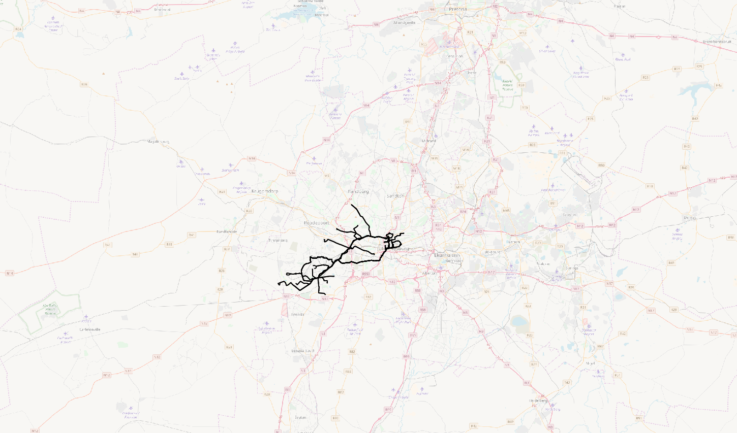
Figure 1: Rea Vaya – Phase 1A and Phase 1B

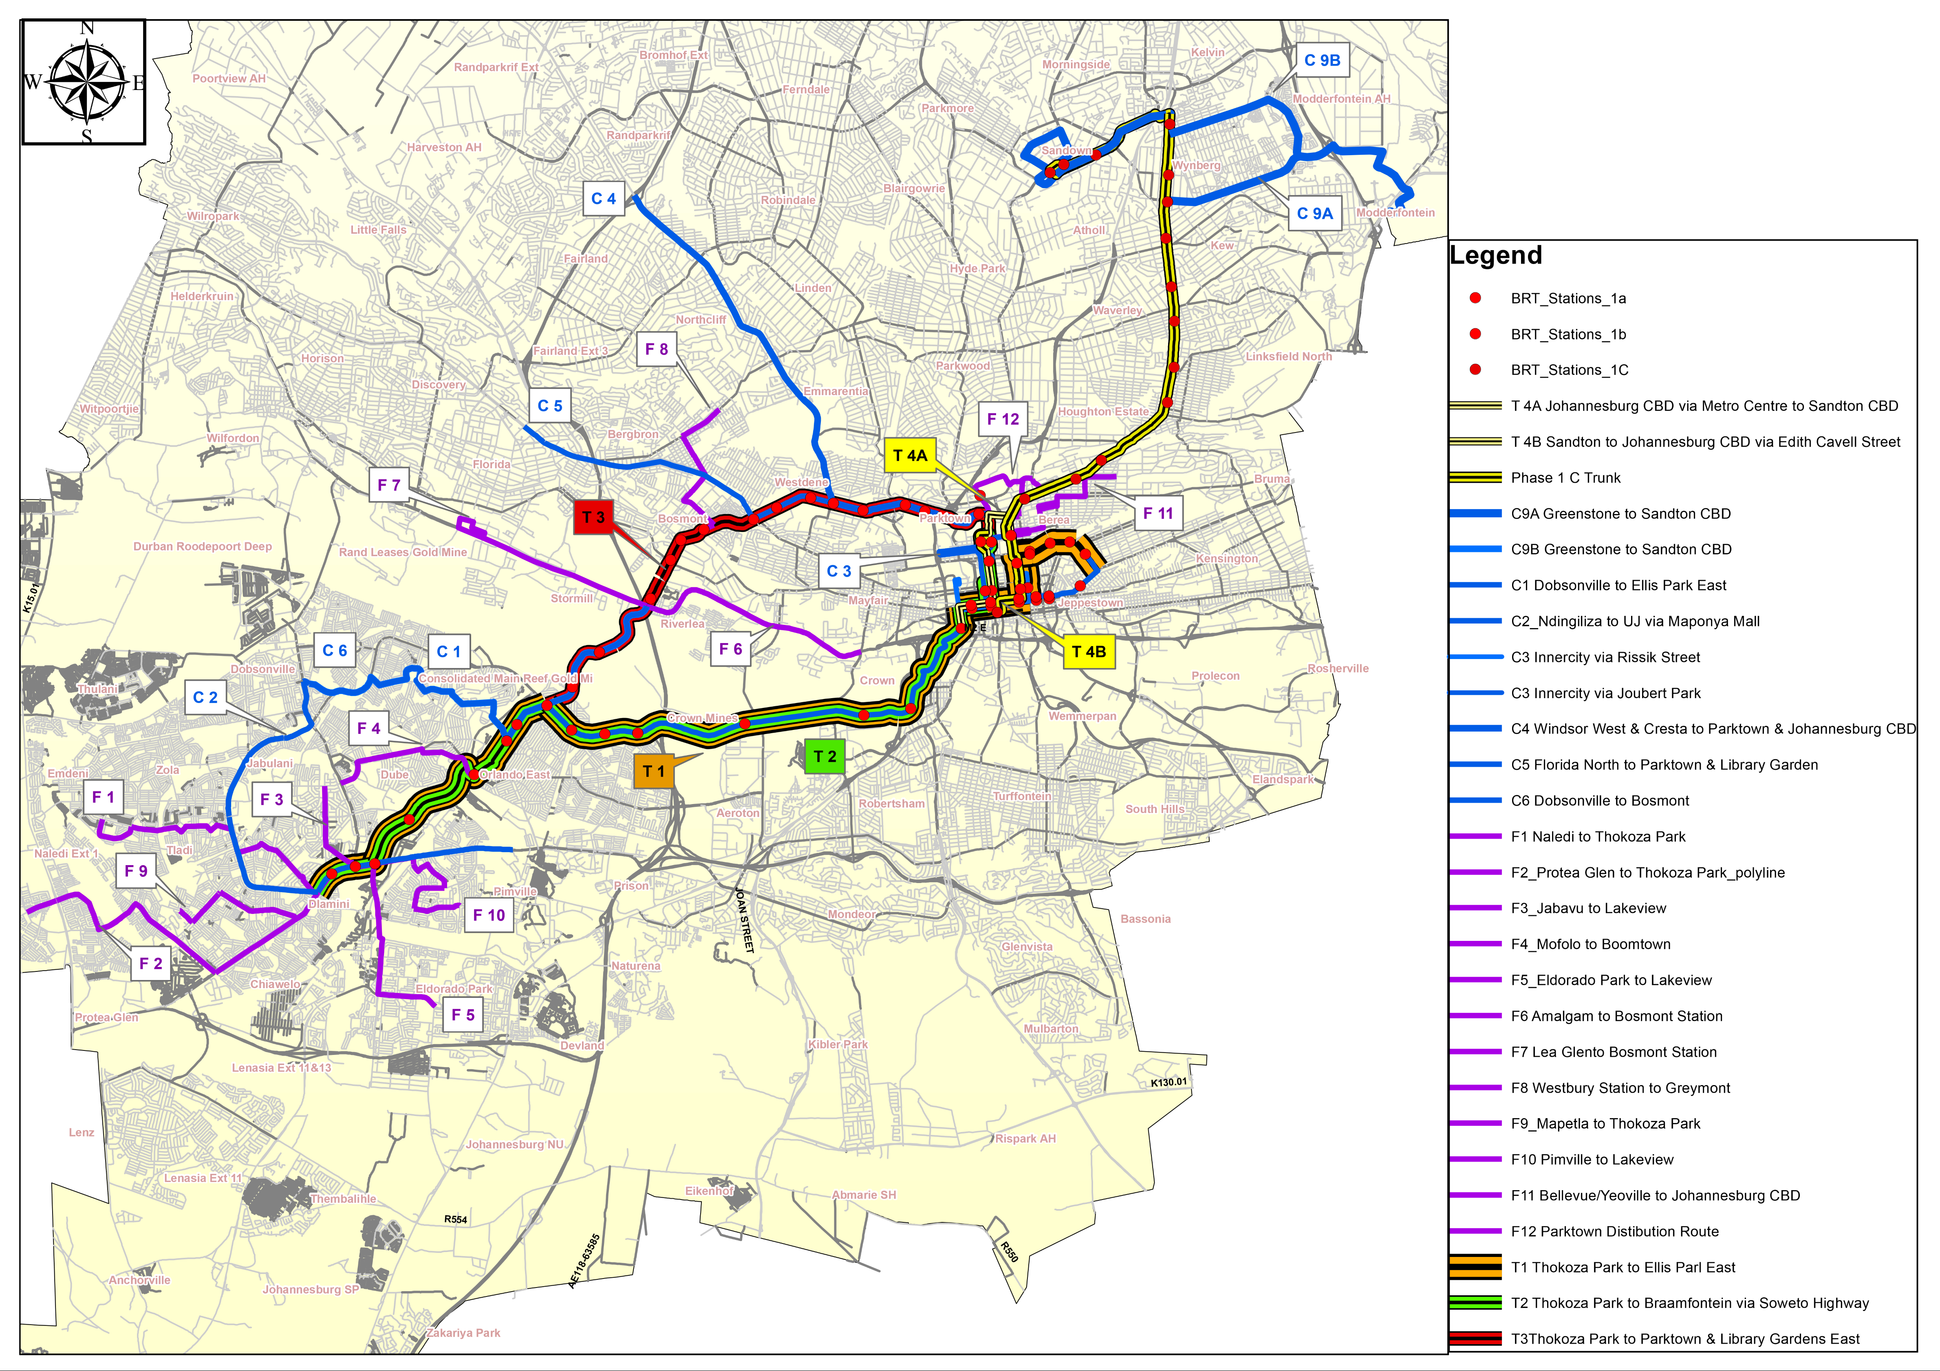

Figure 2: Rea Vaya – Phase 1C

The illustrations within Figure 1 and
Figure 2 shows the network extent for the Rea Vaya Phases 1A and 1B, and Phases 1C.

Part C3.1.3 IRPTN Reference Documents
For context purposes, it is important that the tenderer familiarize themselves with the following documentation available in Volume 2B – Part C5:

Table 1: IRPTN – Reference Documentation
Volume 2B:
Part C5: Annexures
C5.7 | COJ - AFC #20 - Non-Returnable - Vol 2B - Part C5.7 - Annexure F - Rea Vaya Fare Policy 1
C5.7 | COJ - AFC #21 - Non-Returnable - Vol 2B - Part C5.7 - Annexure F - Rea Vaya Fare Policy 2
C5.12 | COJ - AFC #26 - Non-Returnable - Vol 2B - Part C5.12 - Annexure K - Rea Vaya - Phase 1C Ops Plan
C5.13 | COJ - AFC #27 - Non-Returnable - Vol 2B - Part C5.13 - Annexure L - Rea Vaya - Phase 1C Stations

PART C3.2 AFC SYSTEM VISION
Figure 3, Figure 4, and Figure 5 illustrates a generic Topology for the purposes of this tender. Within the illustrations, darker shaded components are supplied and/or provided by COJ or other Contractors. The purpose this Topology is to “break-up” the envisaged Automated Fare Collection (AFC) system in as much components/modules as possible. This “break-up” will then facilitate in cost optimization (Design-Build period), and maintenance (Operations period) management.
It is understood that Original Equipment Manufacturers (OEM)’s equipment do not necessarily adhere to this Topology. For instance, certain modules/components may be manufactured as a single module and/or component (As example: An OEM may have a fare reader that has all the functionality built into a base configuration device that cannot be removed and/or replaced at a later stage). This is accepted and understood. It is however the responsibility of the Tenderer to ensure that:
- Bidders’ system can achieve the desired functionality illustrated and defined within Volume 2B – Parts C3 and Parts C5;
- Bidders’ proposed system is priced in the smallest modular and component denomination; and
- Bidders’ considers all components/modules that is required to achieve the functionality and requirements.
- Incopration of Jakob Nielsen's 10 general principles for interactive design

Please note: Providing and pricing for “aggregate components/modules” when they can be replaced/repaired in a smaller denomination/configuration at a later stage is grounds for:
- A Tender to be considered “non-responsive”; and
- A Contract to be considered for termination.

Part C3.2.1 Automatic Fare Collection
Figure 3 illustrates the Automated Fare Collection topology proposed. It should be noted that the Vehicle Automated Fare Collection (AFC) component was deliberately left out in Figure 3, and included in the next section (this was done only to reduce the complexity within the drawing illustrated only). It is the responsibility of this tender to provide all AFC and Vehicle Technology components that has not yet been described within the previous sections, and as listed within the Schedule of Quantities.
Throughout the fare collection system it should be noted that cash on the vehicles will not be accepted. The system should be able to accept fare media other than approved by the National Department of Transport (NDOT EMV and Cipurse Card) this includes VISA, Mastercard and AMEX for payment will also be accepted .

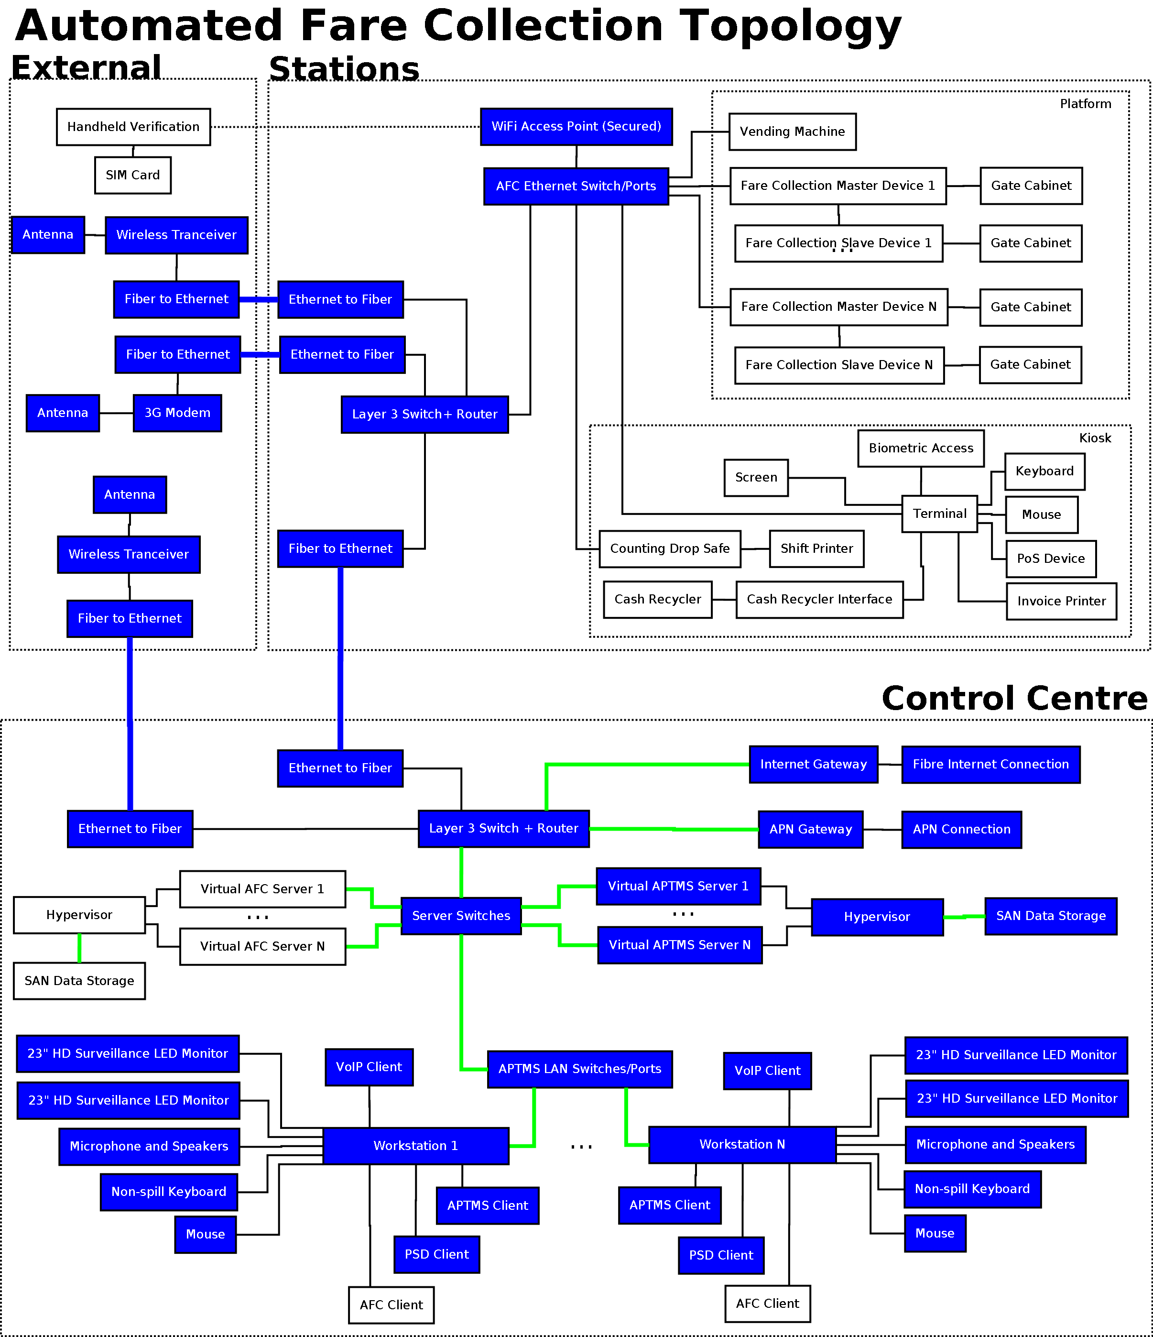
Figure 3: Automated Fare Collection Topology Proposed

- The fare collection functions on the stations consist of the primary attributes below:
  - Fare collection and verification; and
  - Fare media issuance (Prepaid debit Mastercard, VISA with NDOT data structure), information, and reloading.
  - Reloading of EMV wallets
  - Reloading Cipurse cards supplied by others
  - be able to initialise EMV token (if card does not have NDOT data structure)
  - Support all customer related functions from refund of stored value to reissuing where possible.
  - QR code generation via third party retailers and usage of QR codes as method travel.
- Fare media, together with an information leaflet and terms and conditions pamphlet, will be sold at the kiosks by an operator (another contract) who will accept either cash and/or bank issued payment media. Cash will not be controlled by the Cashier at most Reavaya interchanges. All cash (coins and notes) transactions will be done by the Commuter through a Cash Recycling system to be provided under this contract.
- Once the “transit product” and/or the “pre-authorised debit” amount/quantity has been selected by the Operator, the Commuter will provide an Electronic Cash Acceptance Device the tendered amount, and receive change from it as well. No cash will transfer between the Commuter and the Kiosk Operator. Cash-in-Transit (CIT) agencies (another contract) will collect the cash periodically/randomly as per their service level agreements. All Cash Acceptance Devices must be approved by a minimum of three CIT companies.

- When fare media are “reloaded”, the operator will insert the fare media into the EMV Point-of-Sale (PoS) device/terminal and execute the reloading function as per his/her standard operating procedure. The PoS will also be used to provide information (transaction history) or diagnostics for the commuter related queries. Invoices will be issued without request for the payment and reloading of the fare media.

- The Fare Media data structure may be customized to cater for the minimum of the following time constrained subsidy/discount indicators such as (this does not reflect the accepted fare policy and/or fare regime for the Rea Vaya service currently, however, the capability is required):
- Applications for any special concession will be done using online form and work flow management tools provided by the bidder the following concessions will be handled online:
- Scholar;
- Elder;
- Disabled;
- IRPTN Employee;
- Municipal Employee (and their associated department); and
- Maintenance Contractor or other company.

- The loyalty program shall be based on accumulating travel usage value over a single system-wide configurable time period:
- Travel usage value shall be converted to loyalty points according to a single system-wide configurable conversion rate.
- The traveller shall be able to redeem accumulated loyalty points to purchase transit products from the standard product catalogue, i.e. loyalty points are in a closed loop.
- The traveler shall sign up and accept the terms and conditions to benefit from the loyalty program.
- The loyalty program shall be an Account-Based scheme, i.e. no loyalty data shall reside on the fare media.
- Provide a QR code for single and double trip travel and support 3rd party product sales

- Positive identification will be required for the commuters to be eligible for the subsidy/discount indicators. Each usage of the subsidy/discount fare media will be recorded thus enabling the ability to reference the usage via video surveillance footage extracted from the Network Video Recorders (NVR) for reconciliation (NVR and Surveillance functionality is part of another contract). These customized indicators will be done through the Terminal computer that will provided to the issuing bank of the fare media the required changes for activation within the fare media, which is finally updated through the PoS device, once it has received the secure update script from the issuing bank.
- Access to the platform will be controlled through access gates where applicable. These gates, also referred to lanes, consist of a cabinet at each side, with a barrier from each side barring the access through the gate/lane. Upon executing a successful “fare collection transaction” with the fare media, the barriers will recede and allow access through. Override buttons for the lanes must be provided for each of the lanes should any AFC equipment malfunction. The override buttons will be located in the ticket kiosk and must be clearly labelled.
- Each “override event” will be recorded and must be able to be correlated with the video feed of the operator and the commuter/employee using the override situation (NVR and Surveillance functionality is part of another contract).
- Fare readers/processors will be installed within the cabinets at each end of the lane, on purpose made stainless brackets that will allow the readers to be mounted beneath the “way-finding” part of the cabinet. No ad hock mounting of the reader will be allowed on the outside of the cabinet. The fare media readers will be connected to their own battery backup power contained within the cabinets where applicable. On power failure the gates need to be able to open until power has been restored.
- Each access gate cabinet will be mounted on a stainless steel mounting plate that will be able to be levelled through cage bolts to reduce any mechanical strain that can occur due to incorrect levelling. Sleeving to and from the cabinets will be done through core drilling into the manhole beneath the station. Within the manhole, wire baskets and/or cable trays must be installed to reticulate power and data cabling to the server room/cabinet accesses.

Part C3.2.2 AFC Park and Ride
- The COJ requires that the AFC System be able to provide for a Park-and-Ride system that uses the same payment media (EMV Debit Credit Card, NDoT AFC Data structure Bank Issued Fare media, QR code Issuance and Usage, Cipurse 4k T card which is supplied by others). The business rules (how they integrate with the fare rules) associated with the Park-and-Ride facilities will be provided at time of award.

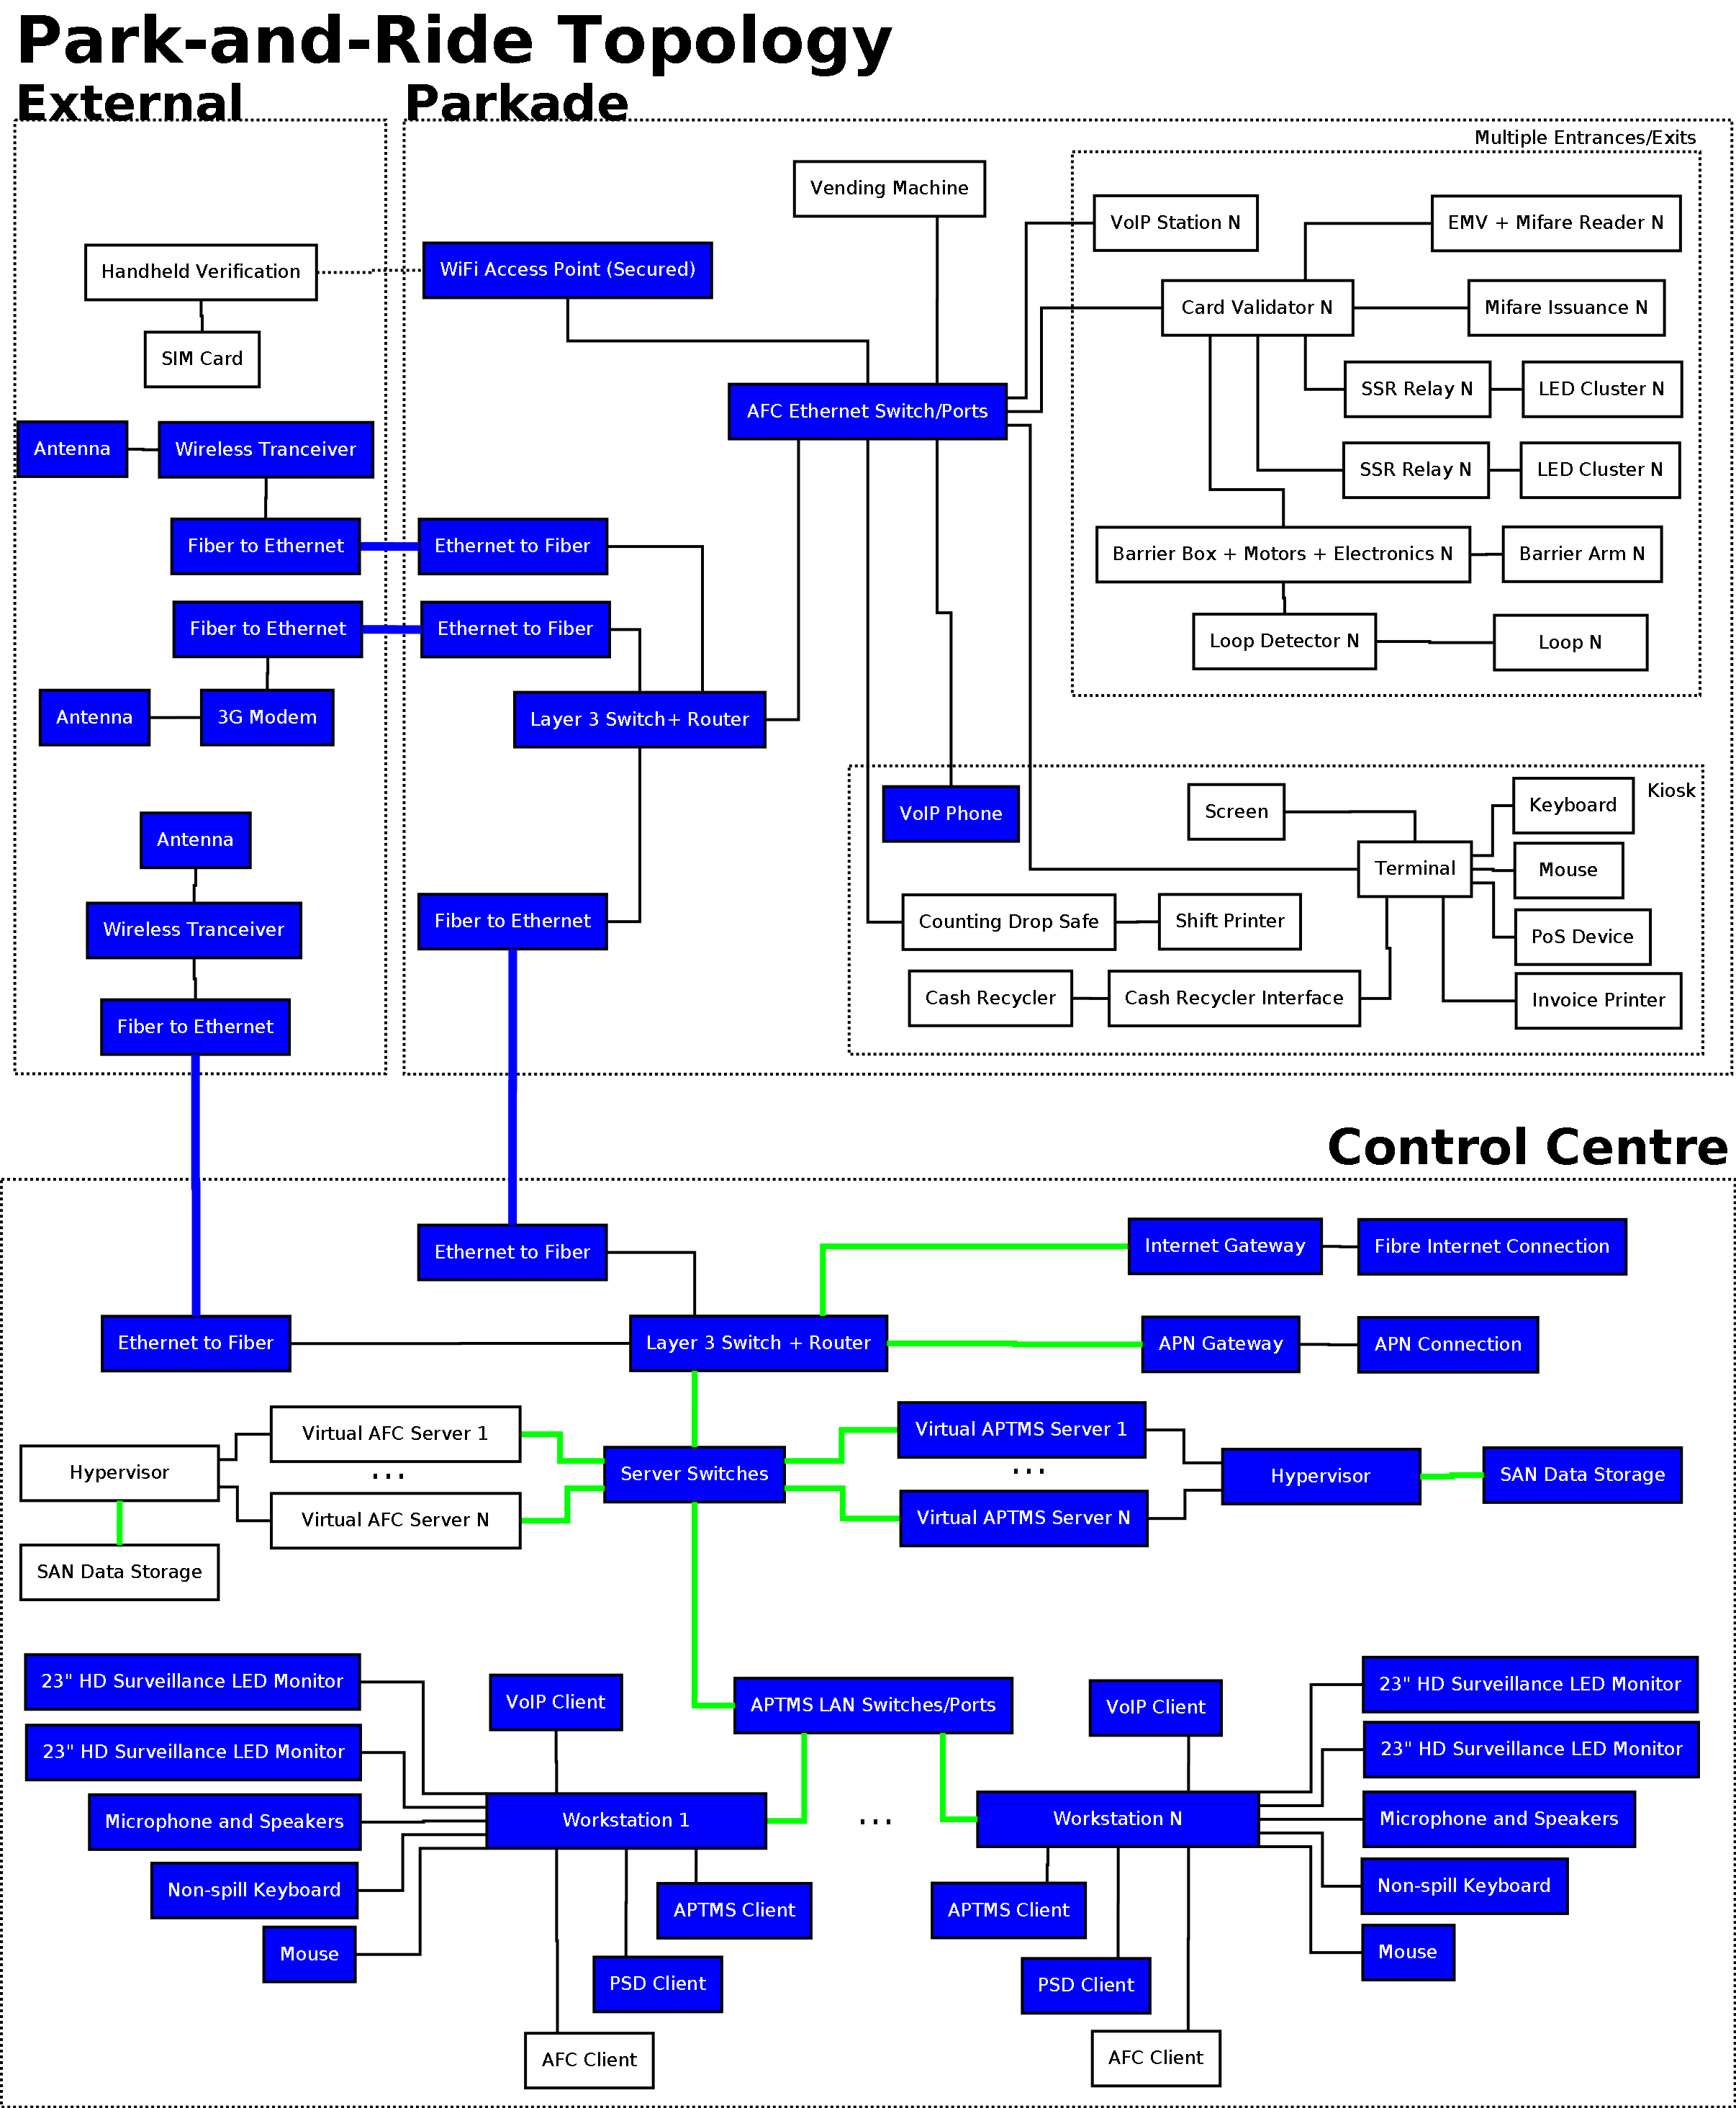
EMV + Cipurse +QR
EMV + Cipurse +QR
Figure 4: Park and Ride Topology Proposed

- It is envisaged that a vehicle will enter the parkade (parkades will be identified when agreements have been finalized with the parkade owners). Upon entering the vehicle will be barred from access, a red LED traffic light will be lit, until a fare media (EMV or Cipurse V2 4k T-Card) has been presented for registration. It is envisaged that the system will only register the entry time of the fare media.
- Once validated, the validation device will open the boom and change activate the green LED traffic light and deactivate the red LED traffic light once the boom is in the open position. Only when the vehicle has safely left the boom area, which is detected by an induction loop sensor, will the validation device close the boom, and revert the LED traffic light status for the next vehicle.

- Payment will be done either at a Vending Machine situated at the premises of the parkade, or the Ticket Office Machine (TOM) also situated at the parkade premises, or at exit with an EMV card, which will obtain the entry data from the AFC System, calculate the charge, and deduct/charge the amount at exit or the Vending Machine.

- Should the driver have trouble at the entrance and/or exit, a VoIP station will be available for contacting the TOM and/or AFC Back Office Control Centre. The VoIP station needs to be supplied under this contract, the SIP PABX is provided under a different Contract.

Part C3.2.3: AFC Vehicle Technologies
Figure 5 illustrates the topology followed for AFC Vehicle Technologies as well as how they interact with the Stations and other External entities.

- Several functions previously discussed under the previous sections are similar in nature within the vehicles as they occur within the stations. The primary difference is that the vehicles do not have the high speed data communication methods to communicate to the back office on a continuous and cost effective means. Symmetric wireless data communication will not be implemented for the vehicles.

- All vehicles will have a road side fare media reader installed and based upon the fare regime, collect the fare from the fare media. Upon a successful “fare collection transaction” an audible and visual confirmation will be provided ( if successful green light will show, if balance is low yellow and unsuccessful red) if . Upon an unsuccessful “fare collection transaction” a different audible and visual confirmation will be provided.

- The fare media reader will utilize its own Global Navigation Satellite System (GNSS) to determine its position, and will not have to integrate into the Bus Monitoring / Contract Monitoring (BMCM) system.

- As part of the verification of roadside commuter boarding, an overhead passenger counting sensor set able to detect multiple entrances and exits simultaneously will be installed above the vehicle doors (roadside and platform side). These types of sensors must have the capability to distinguish between boarding and alighting during mix traffic (people entering and exiting at the same time). This information will be transmitted as part of the financial data to verify passenger counts versus financial transactions received.

- The capability and configuration must exits to transmit this boarding/alighting and financial information at intervals and/or when a threshold is reached where the financial transactions and the boarding and alighting information starts to deviate from a configurable threshold.

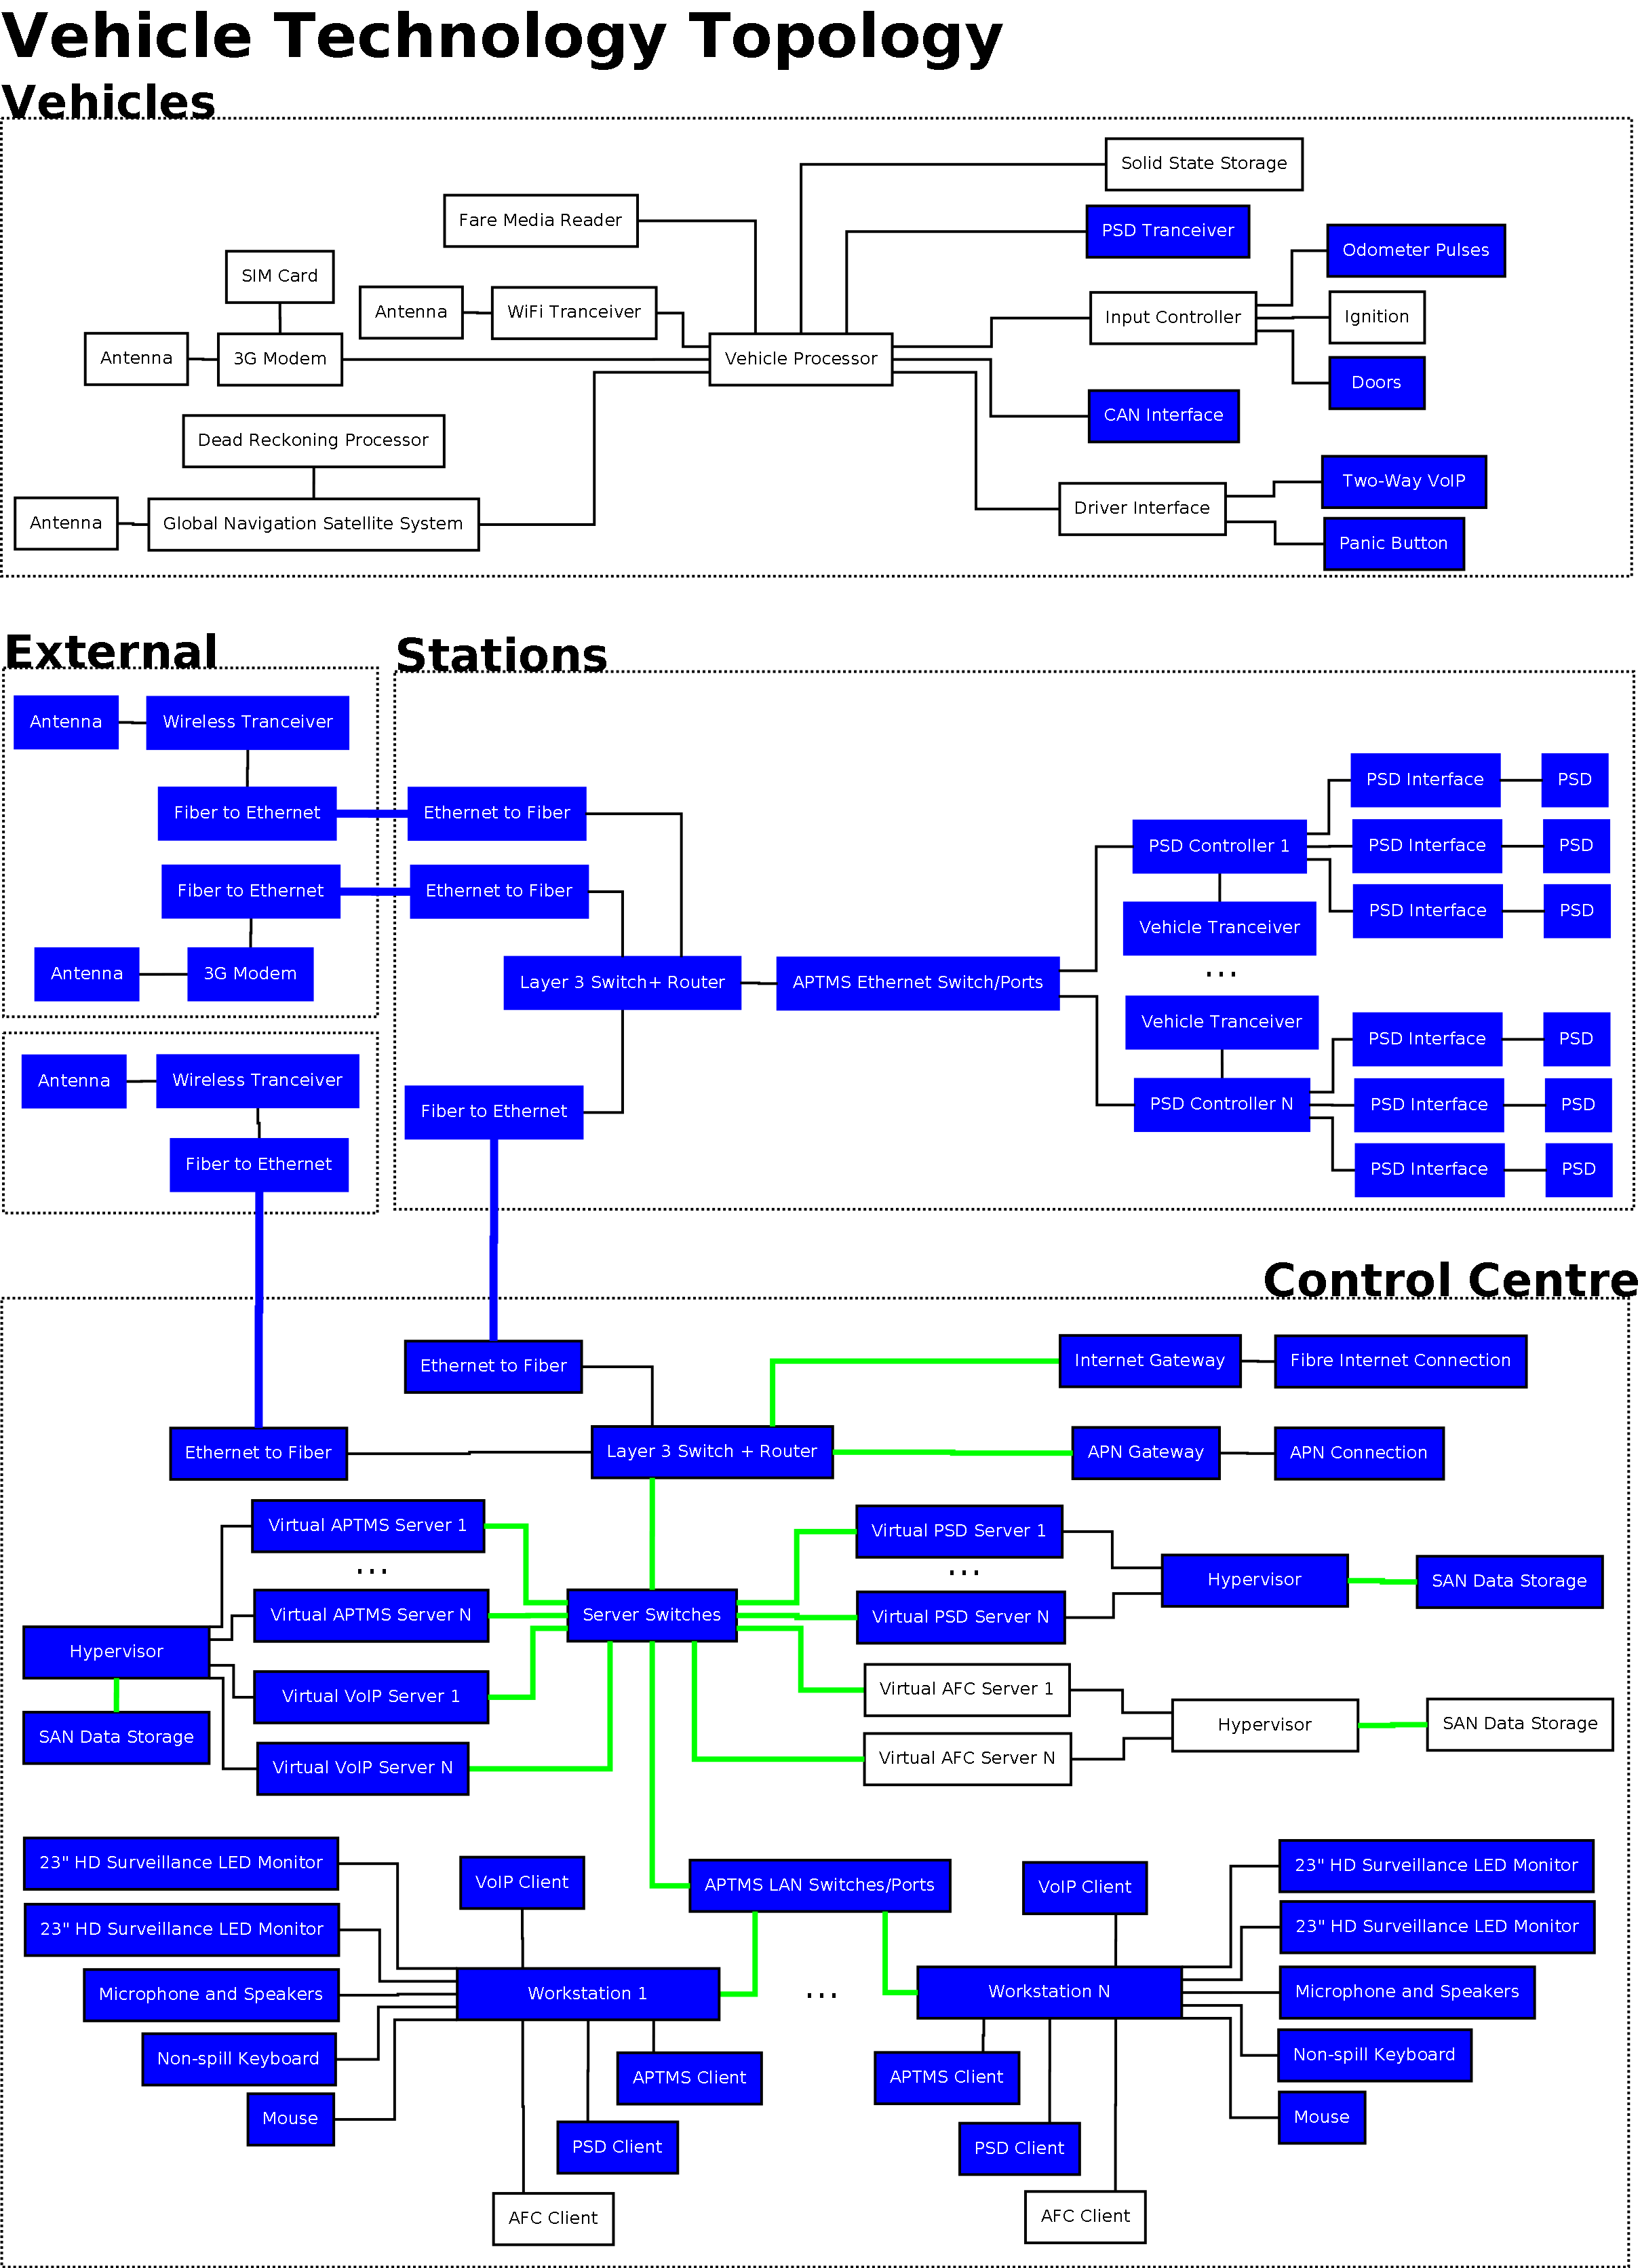
Figure 5: AFC Vehicle Technologies Topology

Service description
- This section describes the services offered by the Fare Collection system;
  - Core Fare services support the core functions of the ticketing business: fare policy management, media management, purchase, validation, after-sale and inspection related services;
  - Customer services include the management of customer accounts, orders, claim tickets and loyalty programs;
  - Operation services are dedicated to the management of the technical resources and agents of the system;
  - Financial services include all the functions in relation with the financial flows between the parties involved in the Fare Collection ecosystem. This includes the customer but also the participating Business Entities;
  - Business Intelligence stores and analyses the business data produced by the sales, travels, payment of services;
  - Integration services are responsible for the configuration and the collect of the operations made locally by the front-end equipment;
  - Security services focus on the back-office staff access right, the processing of the personal data and the security artefacts;
  - Technical framework relies on the infrastructure tools to monitor and upgrade the Central System software components.

Actors of the system
The participating Business Entities operates the Fare Collection system with the purpose of collecting the revenue for the transportation services offered to the Customers.
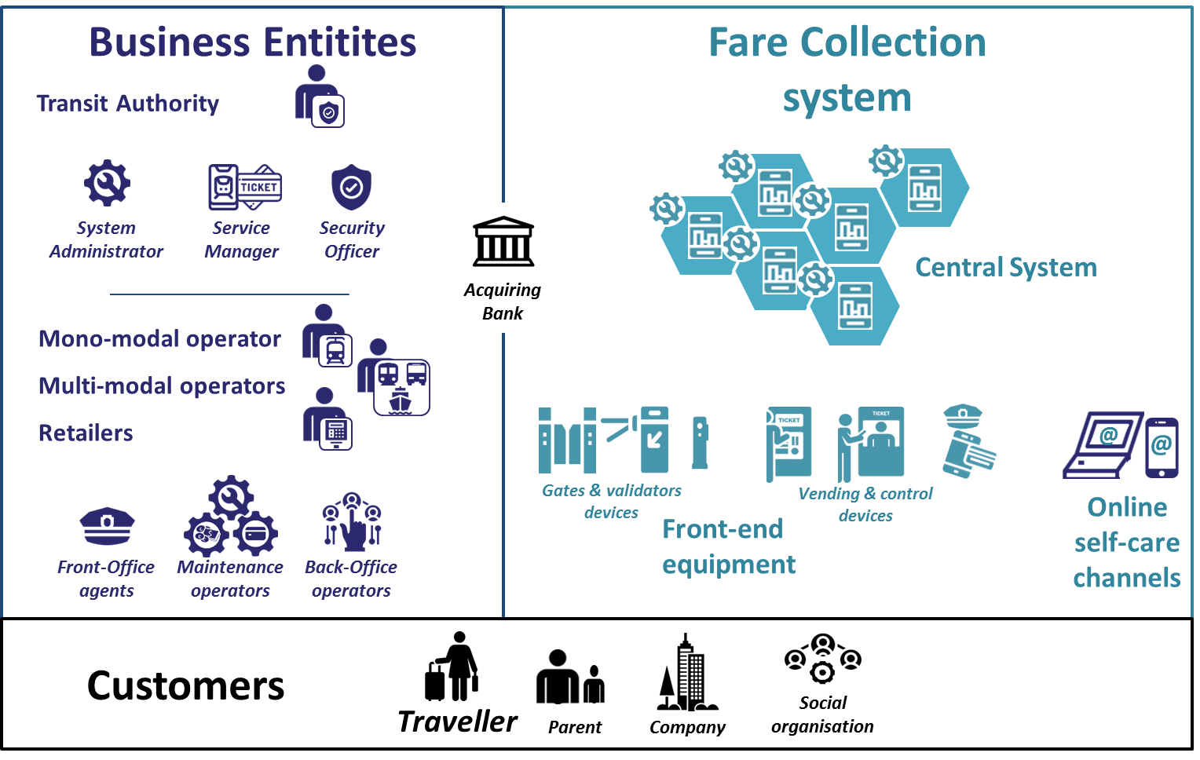
Figure 6 - Actors of the system

Business Entities
- In an interoperable Fare Collection system, a Transit Authority is an organisation that is responsible for creating the common transportation offer for the travellers and for regulating the participating Business Entities. In a Fare Collection system with one operator providing the transportation services, the unique Transport Operator bears the role of Transit Authority.
- The Business Entities select an Acquiring Bank that centralises the collected revenue from all the Customers for later distribution between the participating Business Entities.Transport Operators and Retailers join the Fare Collection system as participating Business Entities.

Customers
- The traveller is the primary customer. Other types of customers are encountered such as parents for under aged travellers or companies and social organisations paying for the transport fare.The traveller accesses the transportation services through the front-end equipment including gates and validators devices and vending devices.
- Online self-service channels are available to the customers for online purchase and transit purse reload.

Fare Collection system
- The Central System software components are deployed as modular services offering the Fare Collection system functions.
- The System Administrator on behalf of the Transit Authority monitors and deploys the Central System services.
- The Service Manager on behalf of the Transit Authority on-boards the participating Business Entities and configure the business ticketing parameters on the Central System.
- The Security Officer appointed by the Transit Authority monitors and controls the security of the Central System and Front-end equipment
- The Front-Office agents working for a Business Entity assist the customer at Front-end equipment.
- The Maintenance operators are deployed on sites to repair Front-end equipment or collect money and replenish the vending devices with Fare Media.
- The Back-Office operators working for a Business Entity monitor the activities of the Front-Office agents, Maintenance operators and Front-end equipment to ensure the best transportation services to the customers

PART C3.3 CONTRACT GUIDANCE AND FORMAT

The traditional International Federation of Consulting Engineers (FIDIC) Conditions of Contract for Design, Build and Operate Projects (The Gold Book) divide the contract into two logical sections as can be seen in Figure 7. That of:
- the Design-Build (DB) period; and
- the Operate-Maintain (OM) period.

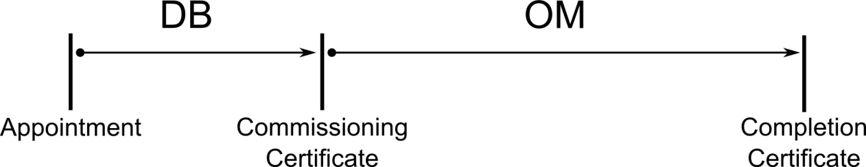

Figure 7: Standard FIDIC Gold Book Timeline

It should be noted that even though the General Conditions of Contract, the FIDIC Gold Book, states a “Design” period, the expected extent of the “Designs” must only be to accommodate said Components within environments and integration into indicated service providers. No new software and/or hardware designs will be allowed. All components must be Commercial-Off-The-Shelf (COTS).

Part C3.3.1: Design and Build Period

Due to the integrated nature of the entire ITS scope of works, the works were divided into specialised portions. The Design-Build period was structured as can be seen in Figure 8. The design should be based on the latest technology available at the time of implementation and best practices.

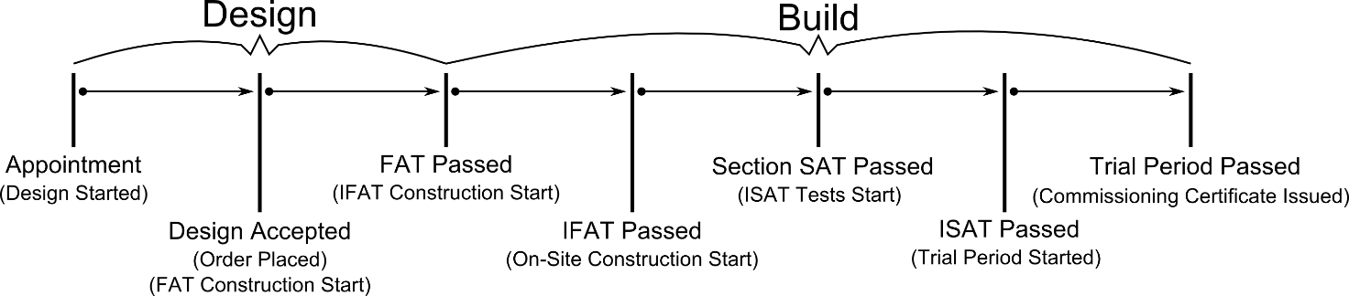

Figure 8: Design-Build Period for this Contract

Referencing Figure 8 (time periods only indicative and do not reflect the expected duration) the Design-Build period will then be as follows:

- Once the prospective Tenderer has been awarded, and the contract has been negotiated (if at al), he will then do his/her design for the AFC Scope of Works at the Commencement Date. The design will be based upon the conceptual building blocks as provided in detail within the Schedule of Quantities and the Architectural and Engineering Specifications for the conceptual building blocks as provided within Volume 2B Part C5 and as amended by the Tenderer. The design must include all the business processes for the operations and maintenance periods. Interim payment certificates for the design period will be based upon a detailed methodology milestones supplied by the tender. If the Tenderer needs a certain conceptual building block to complete his/her design, and it cannot be found within the detailed Schedule of Quantities within Volume 2A Part C2, the building block must be provided for in detail (quantity, supply price, installation, price, and maintenance price) as part of the Tender submission process. Tenderers are not allowed to aggregate building blocks when not part of the base configuration. Doing so will result in the Tenderer to be disqualified (ex. Pricing a Surveillance System (NVR, Cables, and CCTVs) as a lump-sum will be consider grounds for disqualification and/or a non-responsive tender). It is understood that certain products have aggregate functionality as base configuration, as divided within the schedule of quantities within Volume 2A Part C2, the Tenderer must then indicate within the Schedule of Quantities (Volume 2A Part C2) when his/her product provides certain building blocks’ functionality as a whole by writing within the price column: “Included in item X”, where X is the sub-item number the functionality is provided as part of the base configuration.

As an example: “If your “Vehicle Processor” have sufficient digital and analogue I/Os to complete the Scope of Work, and the “Industrial I/O” is not required then the price column should contain: “Included in item X”, where X is the ITEM number column it is included in. However, if the base configuration of the “Vehicle Processor”, can be changed/adapted to have different I/O modules, these I/O modules must be priced separately.

All conceptual building blocks must be accompanied with a datasheet as part of the Tender submission. The detailed Schedule of Quantities will then be used as the basis for the Section Cost calculation after the Design is complete and for Variations and Adjustment as per the General Conditions of Contract;

- Once the design has been accepted by the Employer’s Representative (the responsibility of the design stays with the Contractor) the Contractor will then start the ordering process of the hardware, software, and services. The Contractor will only be paid for design and the value of the equipment that passed Section SATs along with FAT hardware, software, and/or services (less the retention in the Contract Data);
- The Contractor will then commence to construct a Integrated Factory Acceptance Test (IFAT) to demonstrate that the entire proposed system and its respective sub-systems will work in a controlled environment at their premises, with their own supporting equipment that might have been provided in the actual environment (such as servers and communications interfaces). The Tenderer should familiarize themselves with regards to the IFAT requirements within each of the Standard Specifications as provided within Volume 2B Part C5;
- Should the IFAT testing be successful, the Contractor will then be instructed to relocate the FAT testing infrastructure to an COJ provided facility within the Johannesburg area where an Integrated Factory Acceptance Test (IFAT) will commence with the Separate Contractors. An interim payment certificate for the FAT hardware, software, and/or services will then be accepted for payment;
- Depending upon the time availability, and the performance of the other appointed Contractors, an IFAT will be conducted with all the relevant Contracts of the ITS systems to ensure that the entire integrated systems work as expected (such as servers and data telecommunication service providers);
- Once the IFAT testing has been completed to the satisfaction of the Employer’s Representative, or the Client instructs otherwise, the Contractor will then be instructed to commence installation on site. It should however be noted that due to possible time constraints that the IFAT may be done in parallel to the on-site installation, and that minor configuration optimizations will be done based on the outcomes of the IFAT. The Contractor will not be allowed to install on site without written approval to do so. It will be considered as a last effort should the IFAT and on-site installation be done in parallel;
- On-site installation will be in parallel with other Contractors. Security for the infrastructure installed needs to be provided for by the Contractor until the Commissioning Certificate after which COJ will provide Security personnel under a different contract. Damages to others’ work by the Contractor will be born solely by the Contractor. The Contractor does not have to install equipment where electricity and/or air-conditioning installations are not yet finalised. The Contractor needs to ensure that all Occupational Health and Safety aspects are in place before the construction on site starts;
- Continuous site inspections by the Employer’s Representative will ensure that agreed upon quality are maintained. It is the responsibility of the Contractor to provide a full-time Commissioning Engineer that will oversee installation on a daily basis (not to be replaced by the Contractor’s Representative). Once the Commissioning Engineer is satisfied that a Section (whose extents has been agreed upon during the design stage) is fit for a Section SAT, he/she will then inform the Contractor’s Representative of the fact, who in turn will contact the Employer’s Representative. The Employer’s Representative will then execute the Section SAT as per agreed upon during the design stage. Should the SAT be successful, the node will then be paid for less the retention amount as per Contract Data provided in Volume 2A Part C1.2 for the Section in question as per Volume 2B C3.5, or as otherwise agreed upon during design stage;
- Once the Section have passed the SAT, and depending upon the time availability, and the performance of the other appointed Contractors, an ISAT will be conducted with all the relevant Contracts of the ITS systems to ensure that the entire integrated systems work as expected;
- Upon successful completion of the ISAT, the Commissioning Certificate will be issued for the section in question. Should an individual node fail the ISAT test, then that node will have to be re-tested individually;
- Only when the ISAT and IFAT of a specific section has been successful will the retention money as per the Contract Data provided in Book 1 of 2, Subsection C1.2 be released for payment to the Contractor;

TENDERERS ARE URGED TO REVIEW VOLUME 2B PART C3.5 IN DETAIL AND UNDERSTAND THE SECTION OF SECTIONS MECHANISM THAT WILL BE UTILISED TO FACILITATE MULTIPLE RETENTION PERCENTAGES FOR THE SAME SECTION. THE INITIAL AMOUNT OF RETENTION MIGHT SEEM TO BE HIGH, BUT DUE TO THE WAY FIDIC UTILISES SECTIONS FOR PAYMENT, A SECTION OF SECTIONS APPROACH WAS ESTABLISHED.
For instance: Once a section (as an example: a single station of Type A) is completed (IFAT and ISAT), the then contractor, will be provided with half (50%) of the retention amount, once that specific station was completed (IFAT and ISAT) as part of a bigger section (in this example Phase 1 A) half (50%) of the remainder of the retention money will be paid, and so on, until all Design-Build obligations can be completed under a single section for the Final Statement Design-Build.

Part C3.3.2: Documents Required Before Operational Period

The tender should be made aware that before the operational and maintenance period the following sets of documentation needs to be made available as a minimum:

- The design documents requiring approval in terms of the Employer’s Requirements;
- The business process documents required for the Business Process Modelling and Workflow sub-systems;
- The build documents requiring approval in terms of the Employer’s Requirements;
- The Standard Operating Procedures and Operational Service documents requiring approval in terms of the Employer’s Requirements;
- The detailed programmes in relation to the design-build and the operation services;
- The acceptance testing procedures pursuant to the Employer’s requirements;
- The as-built documents;
- The Operation and Maintenance plans and manuals; and
- The maintenance manuals related to the Operational, Maintenance and Support Services.

The tenderer is reminded that each Standard Specification within the Volume 2B Section C5 has its own unique documentation requirements for each of the different technology groupings. These documentation aspects of each of the Standard Specifications must also be submitted for approval. Documents to be provided by the Contractor shall be in its original source form, without any limitations and/or alterations.

The winning bidder – will have to replace existing AFC system for phase 1A and 1B, part of your proposal must include and cost a transition of the existing Phase 1A and 1B towards the end of the current AFC service provider.

Part C3.3.3: Operate and Maintain Period

The Operations and Maintenance period will commence as soon as the Commissioning Certificate has been issued. Operations and Maintenance will be according to the Service Level Specification as provided as part of the Contract Documentation within Volume 2B Part C5 and agreed upon during Tender negotiations (if the Tenderer reach that stage).

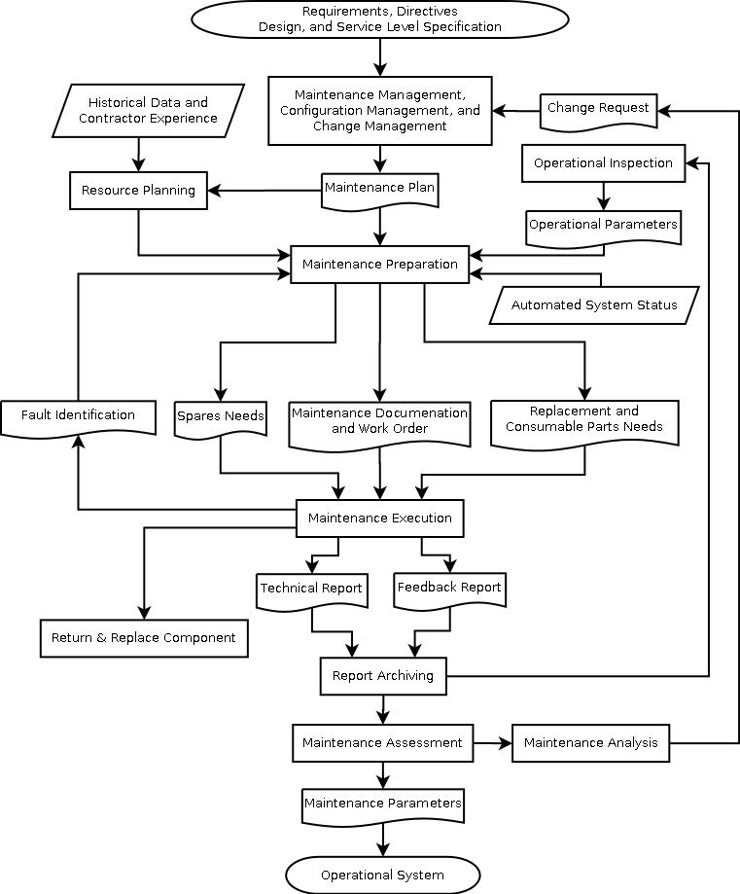

Figure 9: Continuous Maintenance during Operate-Maintain Period

It needs to be highlighted that, apart from active Training, only Maintenance will be considered during the FIDIC Operations period. The AFC System will be operated by others. Figure 9 illustrates the minimum expected Maintenance Processes that the Contractor will have to execute during the contract period (less the Design and Build period). Tenderers need to indicate their Continuous Maintenance Improvement Plan as part of their Tender submission. It is of high importance that Tenderers detail the business processes for the operations and maintenance period during the design build period. The tenderer will be required to use a maintenance management system of the COJ to ensure that Service Levels is unbiasedly monitored by the Employer and/or his Representative. The provision of mobile equipment (such as Tablets) for Maintenance Personnel must also be catered for to streamline the maintenance processes.

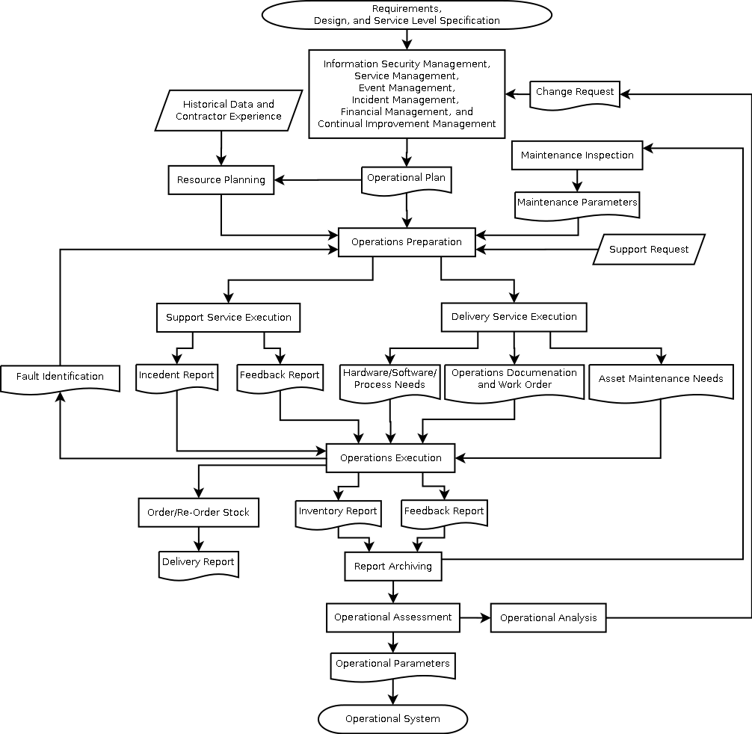

Figure 10: Continuous Operations during Operate-Maintain Period

Figure 10 illustrates the minimum continuous operational functions that need to be considered during the Design-Build period to ensure continuously improved ITS support capability during the contract period (less the Design and Build period).

Items defined during the Design-Build period to be part of the Asset Replacement Schedule, which will be based upon the detailed Schedule of Quantities, will be replaced as per schedule during the Operate-Maintain period in an ITIL and/or ISO 20000 Change Management compliant fashion.

It is of utmost importance that the Tenderer review the Service Level Specifications for the Operate and Maintain period that has to be maintained as it is documented within Volume 2B – Part C5.3 Annexure B: Service Level Specification.

The reasons for the importance are as follows:

- Should the Contractor not perform to the agreed upon Service Level Specifications, he/she will be penalized through deductions of the agreed monthly operate and maintain value. This deduction value will be capped at a maximum of 20% of the overall operate and maintain monthly remuneration value.

Part C3.3.4: Tender Organogram

No tender organogram is supplied, from the Employer, for this project. The tenderer is required to provide a detailed organogram for the Design-Build period as well as an outline for the Operations and Maintenance period.

PART C3.4 SCOPE OF WORK/SERVICES

Part C3.4.1: AFC Scope of Work Summary

The Tenderer should be aware that these services are preliminary and might be extended during the Design-Build period. It is however the responsibility of the Tenderer to indicate his/her capability with regard to the components mentioned above. These components are understood and intended to be integrated in such a way that the Client’s service delivery is enhanced and improved and not limited by the components requested.

These components shall, as a minimum, provide the performance specifications as per:

Table 2: Scope of Work – Detailed Standard Specifications
Volume 2B:
Part C5: Annexures
C5.2 | Annexure A: Standard Specifications: Automated Fare Collection
C5.3 | Annexure B: Service Level Specification
C5.4 | Annexure C: Standard Specifications: Electrical
C5.5 | Annexure D: Standard Specifications: Electronic
C5.6 | Annexure E: Stipulated Minimum Local Production Thresholds
C5.7 | Annexure F: Rea Vaya Fare Policy
C5.8 | Annexure G: National Department of Transport’s Automated Fare Collection Data Structure
C5.9 | Annexure H: Standard Specifications: Information and Communication Technology (ICT)
C5.10 | Annexure I: Standard Specifications: Voice over IP (VoIP)
C5.11 | Annexure J: Standard Specifications: Traffic Control Equipment
C5.14 | Annexure M: mSCOA Requirement  Annexure N: Mastercard-Transit-Solutions-Guide

Part C3.4.2: Equipment Matrix

Table 3: Equipment Matrix – 1 of 1

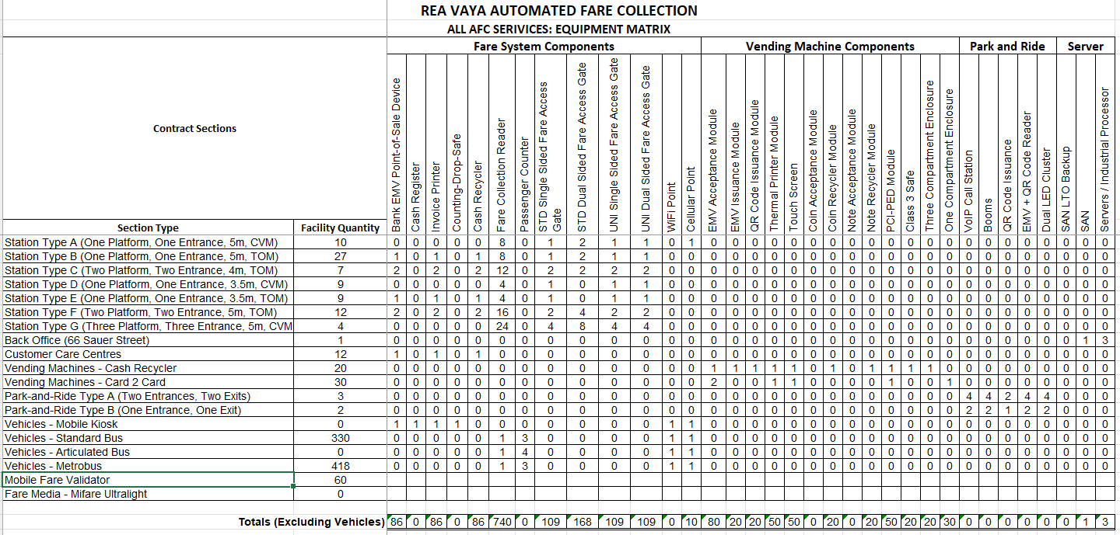

Part C3.4.3: Automated Fare Collection Scope of Work

The Contractor is not required to include an Issuing Bank and an Acquiring Bank as part of the Contract. The Contractor will be required to integrate with COJ’s current banking institution for issuing and acquiring, that of Messrs Standard Bank or whomever the COJ so choose. All EMV transactions accepted at Readers / Validators will be submitted to the payment services provider for processing, after which the acquiring Bank shall credit the proceeds of AFC payment transactions to the Employers bank account within 12 hours after transactions occurred. This must be done in conjunction with a payment processor

It is highly important that the tenderer note that City of Johannesburg (COJ) has opted for a fare structure/policy as indicated within Volume 2B Part C5.7 – Annexure F.

The primary mode of fare payment and access to the Rea Vaya service is through Bank Issued EMV Cards complying with the NDoT AFC Regulations. All EMV cards Single trip tickets (QR-Codes) will be used as secondary and tertiary mode of fare payment (preference will be given to QR-Codes). Cash shall not be accepted for fare payment on buses. Rea Vaya should be seen as the Transport Authority and enabler of fares throughout Johannesburg

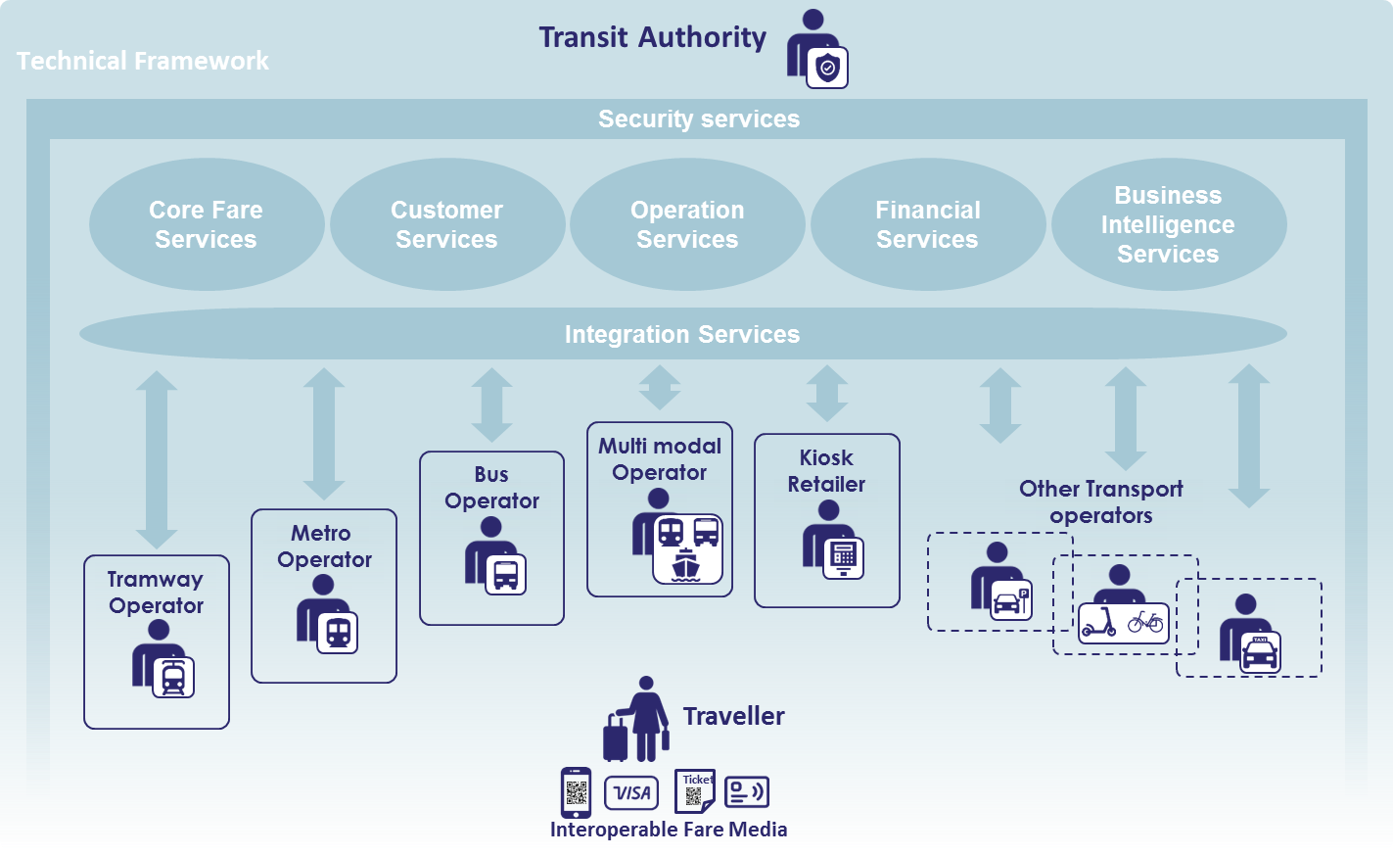

- From the Traveller view. The Traveller will choose the Fare Media with the best benefits in their opinion: anonymous or personalized contactless card, contactless bank card based on EMV technology (Europay, Mastercard, Visa) and Prepaid Debit Mastercard and Visa with Ndot Data Structure, Barcode ticket and smart phones.
- From the Transport Operator and Retailer view. The Transport Operator chooses the association of best cost-effective equipment, with or without best-adapted inspection team. The Transport Operator needs to maximize the revenue against short term and long term expenses. Short term expenses: capital expenditure (CAPEX). Long term expenses: operational expenditure (OPEX).
- From the Transit Authority view. The Transit Authority is necessary in a multi modal and multi operators/retailers environment. The Transit Authority defines the tariff rules to be applied in the geographical transport area.

- The AFC system will have the following standards:
  - ISO 14443 A/B, ISO 18092 (NFC);
  - Cipurse T Card 8K;
  - EMV L1 Certified;
  - EMV L2 Certified (Mastercard, Visa, American Express);
  - EMV L3 ready for each new project;
  - Supporting Mobile payments (Google Pay, Samsung Pay, Garmin Pay,...)
  - PCI-PTS 5.1 SCR (Tamper Proof, Crypto Processor, Secure Element)
  - Modular build, other applications are available (Discover, JCB, CUP, ...)
  - Accept QR code

- The Automated Fare Collection System will support :
  - 3rd Party EMV open loop card issuance:
  - AFC Data Structure
  - Use 3rd Party system operator to do the following for all Rea Vaya EMV open Loop cards
    - User authentication and Know Your Customer
    - Activate and Issue virtual and prepaid cards
    - Develop an EMV digital wallet (that is open to spend in transport and other 3rd Parties)
    - Fraud detection
    - Reconciliation tool
    - Online payments
    - a City of Johannesburg EMV open loop transactions
    - Merchant acquiring
    - Merchant issuing

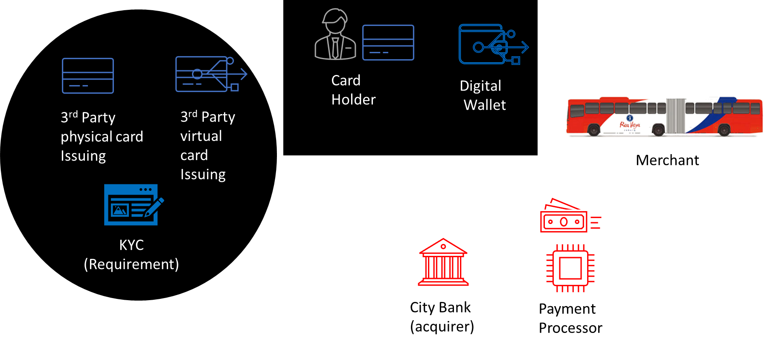

- Account Based Ticketing (EMV Open Loop)
- Model 1: Single Tap - Pay as you go Model
  - Previously termed (Standard Retail Model); A pay-as-you-go model with a known fare, for Transit operators. This is based on an existing pay-as-you-go model that was developed for the retail environment.
  - In this model, the fare is known beforehand – it is either a flat fare, or inputted into the device by the driver or customer before the transaction takes place.
  - The customer only touches in with their card or device at the beginning of the journey (as the fare is already known).
  - The fare is charged to the customer’s issuer and will then be viewable on the customer’s issuer statement
  - The model offers transit operators an ‘entry level’ use of contactless cards as an alternative to cash payments
  - This model does not require an account based back-office because fares is immediately set at usage.
  - Applicable: This model is suited to low to medium value single operator bus and station services.

- Model 2: Aggregated - Pay as You Go Model / MTT
  - A pay-as-you-go model where an aggregated fare is charged at the end of the day or a completed chargeable fare is charged, for single and multi-mode operators (including bus, station, metro, train).
  - This is based on the existing pay-as-you-go model that was developed for Transport for London. The model supports unknown and variable fares on trains (using touch in and touch out).
  - Flat or known fares are supported on buses (uses touch in only).
  - The fare is calculated at the end of a defined period (e.g. day) or after a completed chargeable fare by processing all the taps and calculating the appropriate fare
  - Daily or weekly or monthly caps can be applied to this system. This means once passengers tap around the transport network, once the specific capping value is reached the system stops charging the passenger until a new capping period starts.
  - Via aggregation you reduce the cost per transaction. The final charge will generally appear on the customer’s issuer statement the day after.
  - The system runs on an account-based ticketing office that calculates the different fares based on the secure token (here a cEMV based token) linked to the passenger.
  - Applicable: This model is suited to low to medium value multimode operators, including train, underground, bus & BRT services (e.g. mass transit and commuter). Please see annexure N

- Support the top-up of prepaid stored value or loading of a transit product (such as a preferred Points system) onto the Rea Vaya card and other Bank Issued EMV Cards utilized within the Rea Vaya system. These NDoT AFC Data Structure approved cards are from the following issuing banks:
  - Absa Bank (Previous banking partner); and
  - Standard Bank (Current banking partner).

- The placement of vending machines that will:
  - Load of COJ Rea Vaya EMV Cards and as well as initialisation of the NDOT AFC Data Structure resident on the cards;
  - Initialisation of EMV token (if card does not have NDOT data structure)
  - Sale of Single Trip Tickets or period passes (electronic and/or paper based QR code);
  - Top Up of SANRAL ABT Cards
  - Issue QR-Code single trip tickets (provided by this contract); and
  - Reload Rea Vaya EMV Cards either through:
    - Bank issued card.
- The integration, through a Secure Access Module (SAM), with a third party Fare Collection provider to honour transit products loaded by others;
- The contactless fare payment transactions (such that the system will deduct the appropriate value from the card or accept an appropriate transit product loaded on the card each time the passenger uses the card to access the Rea Vaya System) at stations and on board buses;
- The inspection of cards by inspectors using handheld devices to verify that passengers have valid cards and that they validated their cards at the entrance to the Stations;
- The creation, storing, and analysis of records for each transaction;
- The financial processing of transit products loaded and fare payment transactions; and
- Be able to use Cipurse V2 Cards based on Account Based Ticketing Framework
- Allow for the loading of travel products by 3rd Party Retailers through the use of payment processor

- On completing of the Design-Build, the Contractor will be required to provide the following services during the Operation Service Period:

  - Technical support;
  - Scheduled preventative maintenance for systems, software and cards are required;
  - Corrective maintenance (on-call repairs and replacement services); and
  - Data transmission of transaction records (top-up transaction information to the issuing bank and fare payment transactions to the acquiring bank as well as financial reconciliation with the COJ).

Part C3.4.3.1 – Account Based Ticketing
- The value or ticket information is stored in the back-office of the system (read: servers);
- The traditional transport travel card does not have any value stored on the card chip but acts as identification of the traveller only;
- Media Acceptance Devices (MAD) / validators do not write any data on the transport card or token cards that are used in the system but merely read the ID from the cards to identify the passenger;
- Vehicles and metro gates usually have ticket whitelist and blacklist at present for quick synchronization and offline fall-backs;
- System is constantly up to date and synchronized with back-office in short time periods;
- Customer can use different media (e.g. QR codes, other vendor registered transit cards as tokens etc.) and always have it synchronized with their accounts in the back-office;
- Customers can top-up their cards or buy period passes without going to ticket vending machines or kiosks (that include dedicated proprietary hardware) as the value is store in the back-office;
- In the age of mobility as a service (MaaS), migrating to an ABT system makes perfect sense to most operators.
- The right to travel is managed by the central back office and the "ticket" the passenger has acts as a "token" or proof of the right to travel and identifier of a customer’s account - hence, Account-Based. The back office stores the tokens usage patterns and also settles the transaction (based on usage). As such, the back office is the central storage for rights to travel, unlike in a Card Centric system where it is the card.

Part C3.4.3.2 – Banking Services

No issuing or acquiring banking services will have to be provided under this contract. The Contractor of this tender will however have to integrate with the issuing and acquiring bank of the COJ. However the service provider must ensure that their solution will include a payment processor for reconciliation reporting and integration into 3rd party retail networks

Part C3.4.3.3 – Transfer Rules

Its important of the tenderer to understand the COJ’s understanding of the transfer rules, and how the COJ requires them to be implemented.

When it is not physically possible to stay in the paid area to change bus, then exiting the paid area and entering again is considered as part of the same single journey. The system will allow transferring at the transfer stops, the transfer stops will be known in the system, and different rules are applied according to the product used.

- Rules for transfer applicable for all transfers:
  - At check-out,
  - the stop is known as a transfer stop,
  - the stop is different than the original (initial boarding) stop.
- At check-in:
  - the stop is known as a transfer stop,
  - the previous transaction was a check-out done on a transfer stop within the lapse of time allowed.

- According to the product, different rules apply.

  - EMV products:
  - Pay-As-You-Go/concessions
  - Fare is charged at the first check-out;
  - If a next check-in is done within the transfer rules, the initial fee is not charged;
  - Next check-out: total fare is recalculated. The difference is charged if it is positive; in case the difference is negative, nothing is done.

- CBD:
  - Check-out at transfer station: both stops are CBD, then a CBD trip is deducted;
  - Check-in within the transfer rule: the trip is added back to the card;
  - Next check-out within transfer rule: trip is charged according to the regular rule

- Loyalty:
  - The loyalty program shall be based on accumulating travel usage value over a single system-wide configurable time period.
  - Travel usage value shall be converted to loyalty points according to a single system-wide configurable conversion rate.
  - The traveller shall be able to redeem accumulated loyalty points to purchase transit products from the standard product catalogue, i.e. loyalty points are in a closed loop.
  - The traveller shall sign up and accept the terms and conditions to benefit from the loyalty program.
  - The loyalty program shall be an Account-Based scheme, i.e. no loyalty data shall reside on the fare media.
- Fare Capping Rules
  - Ability to implement optional fare capping, whereby riders pay using open payments This will be configurable in the back office or E-purse value that are then capped at the monthly, weekly or daily pass level.
  - Promotional programs with local or selected vendors for rewards, both for use on transit and conversely for use with vendors.

Part C3.4.3.5 Validation Rules:
- The use of all products is included towards the loyalty scheme;
  - Loyalty is based on the number of trips;
  - Penalty payments will not update the loyalty counter;
  - Checking the loyalty counter can be done on TOM and CVM;
  - Trips part of the loyalty program cannot be used to pay penalties; and
  - Activating your free trips should be done automatically.
  - The final user of a Fare Collection system is the Traveller who uses public transport networks. Travellers can be split into different groups: Frequent Travellers (e.g. Commuters), Occasional Travellers and Potential Travellers. As transport services evolve, the Traveller consumes different types of mobility services driven by state of the art technologies.
- Basically:
  - Traveller is eco-friendly and uses all capabilities of Public Transport.
  - Traveller needs to subscribe and purchase the best services for him/her
  - Traveller has multiple ways to get to his or her destination using different modes of transport.

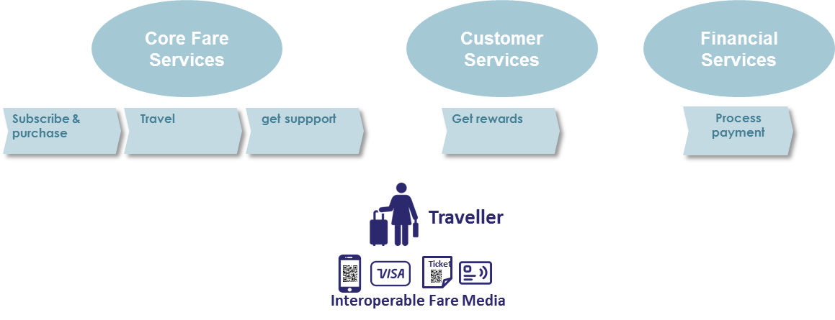
Figure 11 - Traveller view

The traveller subscribes and purchases
- Public Transport has to offer a large choice of Fare Media
- Some travellers will choose a contactless card
  - He/she is proud to be associated, and to benefit from rewards in the loyalty program. The traveller in this case is upgraded to a customer. He chooses a personalized contactless card. And will associate their account to the back office.
  - He/She wants to travel anonymously. He chooses an anonymous contactless card.
  - Some travellers will choose to travel with contactless bank card.
  - For occasional users who use Metrobus and Rea Vaya, they must be able to buy Qrcode Ticket online.
  - Some travellers will use Fare Media on smartphone or associate their value onto other smart devices like smartwatches

- Traveler needs to obtain and reload his Fare media from different sales channels:
  - The traveler can load their card online or at an attended point of sale for the personalized contactless card (Would have associated their value in the back office and linked their card);
  - At an automatic ticket vending machine or at an attended desk and online for the anonymous contactless card;
  - Online for Barcode and Fare Media on smartphone;
  - Online or at a retail attended kiosk to reload his purse on contactless card.

The traveler travels
- Traveller understands he/she has to validate his Fare Media when entering (Check-in) and/or when exiting (Check-out) the Public Transport paid area.
  - On a Reavaya station platform using validation equipment as an anti-fraud gate or standard gate;
  - On-board a Rea Vaya Bus or Metrobus using validation equipment which could be coupled onto a turnstile.

The traveller requests assistance
- Traveller needs support in case of concern with his Fare Media;
  - Information about a service;
  - Refund of overpayment;
  - Block/ Unblock their Fare media;
  - Reconstruction of a contactless card;
  - Support can be online or through an attended desk

The traveller has a high degree of trust regarding different payment mechanism
- Traveller pays services as he/she is used to doing.
  - Either Via their own bankcard,  ,  on website for each purchase;
  - Either Via an automatic bank transfer when his purse passes down an agreed threshold;
  - Via bankcard, at an automatic reload machine Vending Machine;
  - Either Via bankcard at an attended desk or kiosk;
  - Either Via cash at an attended desk or kiosk;
  - Either Via cash at a cash recycler;
  - Either Via Card at a cash recycler;
  - Either Via an EMV bank card used in transit at Gates and validators.

Part C3.4.3.6 The Customer view:
- The customer can be traveller who has chosen to be recognized with special rights within Public Transport. He benefits of loyalty program, discount schemes, etc.
- The customer can be a Company who delivers a Fare Media to its employees with a right to travel on Public Transport free of charge on its journey from home to the Company and return. In addition the same Fare Media can be used by the employee like a Traveller, by reloading the purse of the Fare Media.
- The customer can be a Social Organization like a City who delivers a Fare media to social members. Example: people above 65 years with a right to use Public Transport outside peak hours. Students with reduced fare, etc.
The customer can be a parent who orders Fare Media, manages the right to travel, reloads the Transit Purse for the Fare Media of his children who are the actual Travellers.
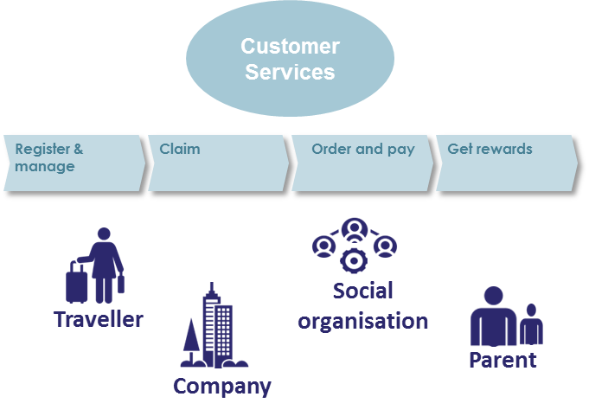
Figure 12 - Customer view

The customer registers in the system:
- The customer registers an account within Public Transport system. There is mutual trust between the Customer and Public Transport Operator.
- The customer registers payment method on Public Transport Operator.
- All customer related issues can be handled by the public transport operator and can be done online or through an attended desk.

The customer makes requests and complains
- The customer requires special attention from Public Transport Operator
- The Customer needs to lodge a claim regarding:
  - Information about the service;
  - Complain about the transportation service;
  - Any commercial issue in relation to the contract between Customer and Public Transport;
  - Any refund that must be issued back to the customer after investigation

The customer gets advanced purchase services
- Customer wants to purchase specific products online:
  - Online reload its anonymous or personalized contactless card. In that case the card is recognized and automatically reloaded on the 1st validation equipment the Customer taps after the online reload (15 minutes minimum between the online reload and the validation taps)
  - Purchase a product via its bank card. Online payment and usage on validation equipment (contactless bank card or Barcode);
  - Purchase a non Public Transport product if any (like a map);
  - Link EMV bank card as a token to a back office (product value);

The customer is rewarded
- Customer would like to benefit from the loyalty program:
  - Loyalty rewards have to be defined within a set of parameters

The Transport Operators and Retailers view
- Transport Operators include; Metrobus or Reavaya or other operators or an operator of a combination of these transport modes. Retailers will be able to use the kiosk application which will be integrated into the retail POS. The retailer will be able to load transit purse and reloads for contactless cards. The Retailer gains a fee on each transaction. The Transport Operator basically carries out an efficient collection of revenues on behalf of the Transit Authority. Main objectives:
  - Reduce of the operational cost of ticketing,
  - Improve the fare collection performance and availability,
  - Apply the fare policy defined by the transport authority,
  - Accountable for the safety and the privacy of the traveller.

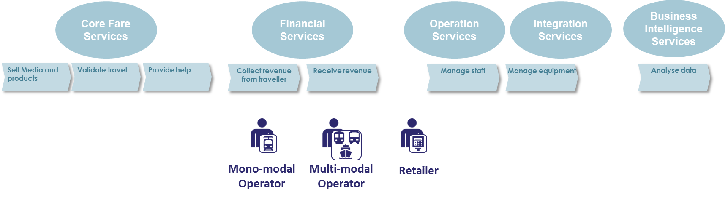
Figure 13 - Business Entity view

The Transport Operator ensures the collection services
- The Transport Operator defines the collection offer:
  - Define the authorized means of payment in your network;
  - transport contactless card of any kind with wallet;
  - personalized transport contactless card;
  - EMV bank card;
  - Barcode;
  - Smartphone;
  - Cipurse Card;
  - Define the tariff rules in the geographical area;
  - In the case of a multi-operator transportation system, it is the Transportation Authority that defines the collection offer.
  - Refer to 3.2.3. 13 Business Parameters Management Service
The Transport Operator provides the services to the Traveler and the Client as described in the preceding paragraphs. These services are defined by the Transport Operator or these services are agreed with the Transport Authority.

- The Transport Operator has control on media and its content
- Transport Operator needs to ensure Transit purse reload services of a contactless card in any front-end equipment pertaining to its network:
  - Automatic Ticket Vending Machine;
  - Gate to enter the paid area on a platform;
  - Validator to enter in a bus or station with self-service validation;
  - Transport Operators share the same reload action in the case of multi-operator transport system
  - Transport Operator needs to refuse service of any Fare Media type.
- Transport Operator applies the service denial for both contactless card and in transit EMV card at front-end equipment belonging to its network:
  - Automatic Ticket Vending Machine;
  - Gate to enter the paid area on a platform;
  - Validator to enter in a bus or station with self-service validation
Transport Operators share the same deny information in the case of multi-operator transport system
- Transport Operator needs to suspend service for any type of Fare Media. Transport Operator accepting contactless card applies the service suspension at front-end equipment belonging to its network:
  - Automatic Ticket Vending Machine;
  - Gate to enter the paid area on a platform;
  - Validator to enter in a bus or station with self-service validation;
  - Transport Operators share the same suspension information in the case of multi-operator transport system.
- Transport Operator needs to accept service for Fare Media in acceptance test phase in any front-end equipment belonging to its network:
  - Automatic Ticket Vending Machine;
  - Gate to enter the paid area on a platform;
  - Validator to enter in a bus or station with self-service validation;
  - Transport Operators share the same acceptance information in the case of multi-operators transport system.

The Transport Operator inspects
- Transport Operator needs to ensure its income and discourage evasion:
  - Inspection equipment must be deployed with the revenue control team;
  - Inspection equipment must be able to check any type of Fare Media: contactless card, contactless bank card, Barcode, Fare media on smartphone, in-transit EMV card.

The Transport Operators and Retailers collect the revenue from traveller
- The solution must provide for travellers, customers, transport operators, retailers and the transit authority in the case of multi-operator, to be able to offer public transport system stakeholders a secured and certified systems of payment from online card purchases for value to card. The solution must provide for the transport operator to fine a traveller who does not adhere to validation rules. The solution will provide the ability of the transport operator to reconcile cash collected through 3rd party retailers so that any sales generated through this channel can be tracked and discrepancies, caused by theft, error in cash counting or in ticket delivery can be quickly identified.
The solution will allow agents and supervisors of a transport operator to check the summary of the activities computed by the equipment, even if cause by power failure, a 5-minute warning will be given and a full receipt of activities for that session will be printed before shutting down.
The solution must provide for the ability of the transport operator to be able to use information from the AFC system for financial reconciliation, stock reconciliation from sale, validation, inspection of shifts and spare part inventory management from maintenance shifts.

The Transport Operators and Retailers receive their revenue
At the end of a predefined period the system provides income to each Transport Operator and Retailer.

The Transport Operators and Retailers operate their equipment and Fare media stock
- Transport Operator or Retailer needs to register and manage any equipment and know about its location and service status:
  - Automatic Ticket Vending Machine;
  - Gate to enter the paid area on a platform;
  - Validator to enter in a bus or station with self-service validation;
  - Reload machine at kiosk
  - Each Transport Operator operates its own equipment in the case of multi-operator Fare collection system
- Transport Operator or Retailer needs to be able to monitor control any equipment and know its location and service status to be able to ensure that maintenance is done if and when a device goes down.
  - Automatic Ticket Vending Machine;
  - Gate to enter the paid area on a platform;
  - Validator to enter in a bus or station with self-service validation.

The Transport Operators and Retailers manage their staff
Transport Operator or Retailer need to give specific access rights to agents according to their agreed tasks in order to guarantee that only authorized staff is using equipment

The Transport Operators and Retailers analyse the ticketing activity
- Transport Operator or Retailer needs to analyse the operational and technical data produced by the system:
  - In case of a multi-operator Public Transport system, the Transit Authority has a right for analysing some data produced by the system.
  - Transport operator can analyse the ticketing activity on its line, on each of its station (metro or bus station), on its bus. This can be done during a defined period of time, an hour, a day, a week, a month.
  - Transport operator and retailer can analyse the ticketing activity by agent and by period of time.
  - Transport Operator or Retailer needs to analyse in near real time the operational and technical data produced by the system.
  - In case of a multi-operator Public Transport system, the Transit Authority has a right for analysing some data produced by the system.

The Transit Authority view
- Transit Authority leads the transport regulation policy in the area of a city, a region or a nation. Main objectives:
  - Guaranty a fair competition, optimisation of transport operational efficiency,
  - Accelerate the shift from car-based mobility to public transportation, reducing pollution, increasing city reachability;
  - Manage subsidies, reduction of expenses in city budget for travel and optimising revenue.
  - Improve user experience and city attractiveness. Inclusion, solution for all the travellers.
  - Transit Authority guarantees Fare interoperability between multiple Transport Operators.

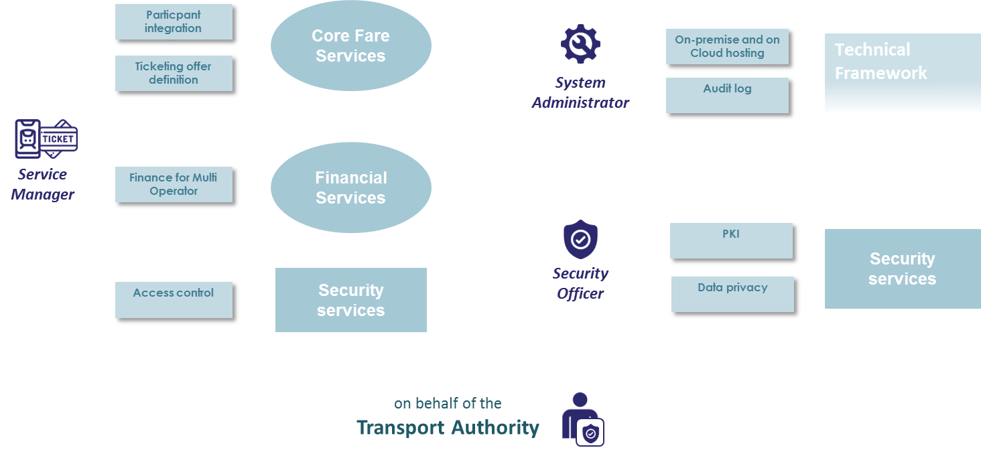
Figure 14 - Transit Authority view

The Service manager on-boards Transport Operators and Retailers
- Transit Authority needs to manage all the Business Entities (Transport Operator, Retailers), involved in providing service within its geographical area;
  - Transit Authority has the full control of each Business Entity;
  - Creating a new Business Entity with proper rules;
  - Breaking access of an existing Business Entity;
  - Managing access of the Business Entity staff to the system

The Service manager configures the ticketing offer
In an interoperable Fare Collection system, the Transit Authority and each Business Entity participating in the public transport network agree the fare policy.

The Service Manager configures the business parameters that support the definition of the topology and fares. In a mono-operator Fare Collection system, the single Transport Operator defines fares for its own public transport network.

The Service manager configures the financial share
In an interoperable Fare Collection system, the revenue sharing is agreed between the Transit Authority and each Business Entity participating in the public transport network.
On basis of predefined tariff rules, the system shares the revenue between the different Transport Operators and Retailers involved in the Traveller’s journeys.

The System administrator manages and monitors HW and SW
The System administrator manages and operates the Fare Collection central system in terms of hardware and software. In case the Fare Collection central system is hosted in the Cloud, the System administrator manages the application software upgrades.

The System administrator monitors and audits the Fare Collection central system. The System administrator prevents faults and errors.

The Security officer controls the security assets
The Security officer protects the system from unauthorised connection to the Central System and stolen equipment through infrastructure key management. The Security officer reduces the Fare Media counterfeiting through ticketing key management.

Part C3.4.3.7- Support the use of SANRAL ABT ticketing framework

The NDOT ABT system (NDOT ABT) is a hybrid ABT system combining back office centric and card centric concepts to provide a fit for purpose fare collection solution that can operate in an online environment as well as sucessfully in an offline situation. Travel and account balance details are stored in the back office with pertinent information also stored on the fare media -in order to facilitate fare collection processes in an offline mode.

The NDOT ABT system enables interoperability of fare media acceptance across the services of all participating Transport Authorities and Operators. This will be achieved by utilising the NDOT sanctioned back office account hosting and transaction processing systems and infrastructure that is provided by the South African National Roads Agency Limited (SANRAL) Transaction Clearing House (TCH), together with its communication links and data processing and storage capabilities.

The proposed AFC system must support the NDOT ABT solution and utilise the NDOT ABT provided back office for the account hosting and transaction processing functions of the ABT solution. The Operator will submit transactions to the NDOT ABT account hosting back office for processing and Mobility Account update.

The ABT solution is based on the non proprietary CIPURSE open standards for fare collection media and validators/readers as supported and published by the Open Standards for Public Transport (OSPT) Alliance to ensure interoperability across all public transport services.

The system functionality is dependent on a Validation List, that stipulates account balances, that will be updated and distributed by the NDOT ABT account hosting back office system and made available to the Operator’s AFC back office. The Operator will download this list at predetermined intervals or events, and distribute to all reader/validator terminal devices connected to the Operator’s back office. When the fare media is presented to a validator at time of travel, the latest balance will be updated to the fare media.

The system functionality is designed to allow for off line fare transaction acceptance at validators as the “open to transact” balance is written and carried on the card.

- Mobility Account

Integrated travel is a critical success factor for sustainable public transport systems. Interoperable fare collection systems are the key enablers of multimodal, integrated travel. In the case of the NDOT ABT system this is facilitated and implemented by using SANRAL’s Moblity Account as the basis for interoperable fare collection functionality.

The SANRAL TCH back office will host the ABT accounts, known as Mobilitty Accounts.. Commuters are required to deposit funds into Mobility Accounts held at the SANRAL TCH to prepay expected usage of public transport services. The Mobility Account stores relevant information related to the balance of value available and that can be accessed by the ABT fare media which is the unique identifier linked to the Mobility Account.

Commuters are allowed the option to register a personalised “Mobility Account” that they can top up by linking a pre-registered payment card or by transferring funds by Electronic Funds Transfer (EFT), or by depositing monies at retail locations. There will also be an option to fund an anonymous account by depositing monies at retail locations countrywide. A network of retail stores with countrywide points-of-presence where monies can be deposited for credit to Mobility Accounts, is already in place and operational.

Registration of a personalised Mobility Account and activation of the Account can be finalised on the internet or by visiting SANRAL specific points-of-presence.

In the event that a commuter elects not to register a Mobility Account an anonymous Mobility Account will be created and activated when the fare media is utilised for the first transaction and this transaction is submitted to the TCH back office. The Primary Account Number (PAN) personalised on the fare media will be linked to the anonymous account as the unique identifier.

- ABT Fare Media

Contactless smart cards will be utilised as a Mobility Account identifier for the initiation of transactions on fare validators and transfer to the back office account hosting system. The smart card carrying the PAN as the unique identifier will be linked to the commuter’s Mobility Account.

The NDOT ABT is a viable Integrated Fare Management solution by providing a single card that meets the common requirements of all partcipating Transport Operators in an Integrated public transport network.

The ABT Fare Media shall be based on and comply with the CIPURSE T card format and will be personalised with a Card Profile that meets the functional requirements of the current NDOT Data Structure Specification utilised on EMV bank issued fare media. The card profile and data file structure specification will be provided by the NDOT.

- Fare Validation

The NDOT ABT is a fare collection system where the balance “open-to-spend” and proof of entitlement to travel is held in the back office account hosting system as well as on the Fare Media. Fare collection can take place in an online as well as an offline environment where appropriate risk management and revenue protection techniques are required. The NDOT ABT system will store information on the fare media as part of these risk management techniques.

Public transport operators will accept CiPurse specified contactless cards, linked to a Mobility Account as fare media for the collection of a fare. Business and Fare Structure rules will be formulated by the Operator for the collection of fares in both an online as well as in offline environments. The downloading of validation lists to Validators on buses and station gates will need to be specified together with relevant business rules to facilitate risk management related to the frequency of downloads to the Operator’s AFC Back Office and subsequent distribution to Validators.

Fare transactions initiated at Validators will be submitted to the Transport Operator’s AFC Back Office, where these will be locally stored and batched and subsequently transferred to the NDOT ABT back office at predermined intervals. The NDOT ABT back office system will process transactions by debiting relevant Mobility Accounts and reimbursing the Operator for all valid transactions submitted by Electronic Funds Transfer (EFT).

The proposed AFC system shall include and make use of Validators that comply with the following requirements.

The AFC systems’s validator software shall:

- Support the CIPURSE V2 Cryptographic Protocol, Revision 1.0, including PLAIN, MAC'ed and ENC'ed modes;
- Comply with CIPURSE V2 Operation and Interface Specification, Revision 2.0 ;
- Comply with all relevant ISO/IEC standards including ISO/IEC-7816, ISO/IEC 7816-4, ISO/IEC 14443-3 and ISO/IEC 14443-4;
- Comply with the CIPURSE V2 SAM Specification, Revision 1.0 in order to facilitate secure transactions. The card readers on Validators shall support the CiPurse T card format.
A complete list of all the required standards that must be complied with can be found in the Cipurse Interface Specification.
In addition to specified Validator software requirements, the AFC systems’s Validators shall:

- Comply with the NDOT ABT Card Profile Specification that will be provided at implementation phase;
- Be able to validate CiPurse fare media issued by all other authorized ABT card issuers;
- Have SAM slots available for both EMV and CIPURSE SAMs and shall support both concurrently;
- Support software embedded SAM deployment;
- Support scenarios where SAMs are stored on offsite equipment that is available through various connectivity options.

High level ABT System Architecture (Picture 6)

Figure 15: High Level ABT system Architecture

The proposed AFC solution shall have its own back office that must integrate with the NDOT ABT back office at the TCH and comply with the requirements of paragraph 1.7 below. The AFC vendor provided back office shall remain responsible for all the functionality required of an AFC system, including communication with and updating validators with the latest validation list(s).
The Operator AFC back office shall perform the following functions:

- Download the latest Validation List from the ABT back office at the TCH, at regular system configurable intervals. The NDOT ABT back office at the TCH will provide an API for the Operator AFC back office to download the latest Validation List.

- Update Validators on buses and gates with the Validation List downloaded from the TCH in predetermined intervals or in real-time.

- Upload transactions from Validators and gates to the Operator AFC back office system at predetermined intervals and when online connectivity can be maintained. If communications with the validator is interupted, it shall update the transaction file with all remaining transactions as soon as communications are restored.

- Upon receipt of the transactions from the validators, the Operator AFC back office will batch the transactions for subsequent uploading to the NDOT ABT back office. The NDOT ABT back office at the TCH will provide an API for the Operator AFC back office to upload batched transactions to the NDOT ABT Back Office. Transactions shall be submitted in predetermined intervals or in real-time if practicable.

- The NDOT ABT back office system at the TCH will process transactions by debiting relevant Mobility Accounts and the Operator will be reimbursed for all transactions submitted.

- NDOT ABT system Interface requirements

It is a requirement of this tender to provide an Automatic Fare Collection (AFC) solution with a back office that will have an interface with the NDOT ABT back office. The Operator AFC back office shall receive validation lists from the NDOT ABT back office at the TCH and will be required to upload and submit transactions to the NDOT ABT back office. The interface with the NDOT ABT back office shall where possible be a near realtime interface for the purpose of downloading the validation lists and submitting transactions.

The main goal of the communications infrastructure between the Operator and the NDOT ABT back office is to provide a reliable, high speed, large bandwidth communication channel to allow close to real-time (online) processing between the parties.

The NDOT ABT back office primary interface for near realtime interaction will be implemented through a standard RESTful API over HTTPS for enhanced security. The API implements its own layer of security by means of using a JWT token authentication mechanism and a HMAC signature for each message.

The Operator AFC back office will use this interface for all operational and configuration functions, such as submitting transactions, configuring locations and obtaining the latest updates for the Validation List.

There will be a secondary interface available at the NDOT ABT back office for bulk and/or deferred operations, based on a File Transfer Hub implemented through an SFTP. The very same data structures and data specifications will be used in both interfaces.

The NDOT ABT back office interfaces will be exposed to the Operator and made available on secured networks, either through a VPN tunnel over the Internet or through a private MPLS network between the two peers. MPLS is the preferred technology as it offers a more reliable and guaranteed network, unlike a VPN over the Internet.

- Account top ups

Commuters fund their Mobility Accounts held at the TCH using existing and any new Operator established top up Locations and channels. Commuters have the option to utilise automated payment services by registering appropriate bank account or payment card details with the TCH, or else convenient payment acceptance Points-of-Presence that are located in the retail sector and/or any other suitable location easily accessible to commuters, for the acceptance of over-the-counter payments and for the convenience of Commuters.

- Register Credit Card

Commuters are able to register their credit card details with a pay-as-you-go option of post paid settlement of Mobility Account transactions or automatic balance top-up based on a preset minimum balance threshold. This facility is available for registered Mobility Accounts.

- Debit Order

Commuters are able to provide bank account details for the funding of Mobility Accounts by interbank debit order services. This facility is available for registered Mobility Accounts.

- Internet Banking

Commuters can transfer monies to a Mobility Account via their banks’ internet banking service. This facility is available for registered Mobility Accounts as well as non-registered anonymous Mobility Accounts

- Mobile Application

SANRAL has implemented a Mobile phone Application that can be used to transfer value to a Mobility Account via a pre-registered credit card in the Application. Full Mobility Account transaction history and balances are available via the Application as well. This facility is available for registered Mobility Accounts

- Retail Points-of-Presence

SANRAL has appointed Agents to provide a countrywide network of locations for the acceptance of over-the-counter top-up transactions from the general public for transfer to a Mobility Account. Top-up transactions can be effected by cash or card payments at major retail stores countrywide.

- Appointed Agents will accept payments from Commuters on behalf of SANRAL.
- Besides the acceptance of cash, retail agents will accept debit and credit cards as a payment method. Debit and credit card payments will be submitted to the agent’s own acquiring bank for processing and the value of the payment transaction is transferred to the TCH for credit of the Mobility Account by the agent via EFT.
- In order to ensure that payments made by Commuters are credited to the correct Mobility Account at the TCH, the card PAN will be the account reference number that will be utilised by the Commuter and provided to the agent at the time the payment is made.
- The account reference number will be validated by the agent by applying a preset validation rule to ensure that only payments to valid account numbers are accepted.
- Transaction details including the amounts, together with correctly validated reference numbers will be transferred to the NDOT ABT back office account hosting system for credit to relevant Mobility Accounts.
- Consolidated transaction batch files will be transferred to Mobility Accounts in multiple data files during a business day.

- Operator Kiosks or Appointed Agents

Operator managed kiosks or offices as well as appointed Agents to provide for the acceptance of top-up transactions from commuters for transfer to a Mobility Account. Top-up transactions can be effected by cash or card payments as determined by the Operator. All attended and unattended Kiosks will have back up 3G routers.

PART C3.5 INFRASTRUCTURE AND SECTIONS
The Contractor will be paid primarily upon the Sections concept as provided within the General Conditions of Contract within the FIDIC Gold Book for the design build period through interim payment certificates.

Part C3.5.1 Sections for Tender Period
The Sections are for the tender purposes only, until approved during the design period by the Employer and/or Employer’s Representative. The Sections for the Tender are as follows (provided in Table 4):

Table 4: Infrastructure and Sections

Section Type Number | Section Type Definition | Section Type Quantity
1 | Station Type A (One Platform, One Entrance, 5m, CVM) | 10
2 | Station Type B (One Platform, One Entrance, 5m, TOM) | 27
3 | Station Type C (Two Platform, Two Entrance, 4m, TOM) | 7
4 | Station Type D (One Platform, One Entrance, 3.5m, CVM) | 9
5 | Station Type E (One Platform, One Entrance, 3.5m, TOM) | 9
6 | Station Type F (Two Platform, Two Entrance, 5m, TOM) | 12
7 | Station Type G (Three Platform, Three Entrance, 5m, CVM) | 4
8 | Back Office (66 Sauer Street) | 1
9 | Customer Care Centres | 12
10 | Vending Machines - Cash Recycler | 20
11 | Vending Machines - Card 2 Card | 30
12 | Park-and-Ride Type A (Two Entrances, Two Exits) | 3
13 | Park-and-Ride Type B (One Entrance, One Exit) | 2
14 | Vehicles - Mobile Kiosk | 0
15 | Vehicles - Standard Bus | 330
16 | Vehicles - Articulated Bus | 0
17 | Vehicles - Metrobus | 418
18 | Mobile Fare Validator | 60
19 | Phase 1 – Super section consisting of:  - 0x Station Type A (Section Type No 1)  - 3x Station Type B (Section Type No 2)  - 1x Station Type C (Section Type No 3)  - 0x Station Type D (Section Type No 4)  - 1x Station Type E (Section Type No 5)  - 4x Station Type F (Section Type No 6)  - 0x Station Type G (Section Type No 7)  - 1x Back Office (Section Type No 8)  - 5x Customer Care Centres (Section Type No 9)  - 5x Integrated Point of Sale - Cash Recycler (Section Type No 10)  - 10x Vending Machines - Card 2 Card (Section Type No 11)  - 0x Park-and-Ride Type A (Section Type No 12)  - 0x Park-and-Ride Type B (Section Type No 13)  - 0x Vehicles - Mobile Kiosk (Section Type No 14)  - 32x Vehicles - Standard Bus (Section Type No 15)  - 0x Vehicles - Articulated Bus (Section Type No 16)  - 418x Vehicles – Metrobus (Section Type No 17)  - 10x Mobile Fare Validator (Section Type No 18)  - Decommission Metrobus | 1
20 | Phase 2 – Super section consisting of:  - 6x Station Type A (Section Type No 1)  - 0x Station Type B (Section Type No 2)  - 0x Station Type C (Section Type No 3)  - 3x Station Type D (Section Type No 4)  - 0x Station Type E (Section Type No 5)  - 0x Station Type F (Section Type No 6)  - 1x Station Type G (Section Type No 7)  - 0x Back Office (Section Type No 8)  - 0x Customer Care Centres (Section Type No 9)  - 0x Integrated Point of Sale - Cash Recycler (Section Type No 10)  - 0x Vending Machines - Card 2 Card (Section Type No 11)  - 0x Park-and-Ride Type A (Section Type No 12)  - 0x Park-and-Ride Type B (Section Type No 13)  - 0x Vehicles - Mobile Kiosk (Section Type No 14)  - 0x Vehicles - Standard Bus (Section Type No 15)  - 0x Vehicles - Articulated Bus (Section Type No 16)  - 0x Vehicles – Metrobus (Section Type No 17)  - 10x Mobile Fare Validator (Section Type No 18)  - Decommission Phase 1A and 1 B | 1
21 | Phase 3 – Super section consisting of:  - 4x Station Type A (Section Type No 1)  - 12x Station Type B (Section Type No 2)  - 3x Station Type C (Section Type No 3)  - 5x Station Type D (Section Type No 4)  - 5x Station Type E (Section Type No 5)  - 6x Station Type F (Section Type No 6)  - 3x Station Type G (Section Type No 7)  - 0x Back Office (Section Type No 8)  - 4x Customer Care Centres (Section Type No 9)  - 15x Integrated point of Sale - Cash Recycler (Section Type No 10)  - 10x Vending Machines - Card 2 Card (Section Type No 11)  - 3x Park-and-Ride Type A (Section Type No 12)  - 2x Park-and-Ride Type B (Section Type No 13)  - 0x Vehicles - Mobile Kiosk (Section Type No 14)  - 234x Vehicles - Standard Bus (Section Type No 15)  - 0x Vehicles - Articulated Bus (Section Type No 16)  - 0x Vehicles – Metrobus (Section Type No 17)  - 30x Mobile Fare Validator (Section Type No 18)  - Deploy QR code and EMV wallets  - Deploy 3rd party issuing and distribution of products throught tokenization framework | 1
22 | Phase 4 – Super section consisting of:  - 0x Station Type A (Section Type No 1)  - 12x Station Type B (Section Type No 2)  - 3x Station Type C (Section Type No 3)  - 1x Station Type D (Section Type No 4)  - 3x Station Type E (Section Type No 5)  - 2x Station Type F (Section Type No 6)  - 0x Station Type G (Section Type No 7)  - 0x Back Office (Section Type No 8)  - 3x Customer Care Centres (Section Type No 9)  - 0x Integrated Point of Sale - Cash Recycler (Section Type No 10)  - 10x Vending Machines - Card 2 Card (Section Type No 11)  - 0x Park-and-Ride Type A (Section Type No 12)  - 0x Park-and-Ride Type B (Section Type No 13)  - 0x Vehicles - Mobile Kiosk (Section Type No 14)  - 100x Vehicles - Standard Bus (Section Type No 15)  - 0x Vehicles - Articulated Bus (Section Type No 16)  - 0x Vehicles – Metrobus (Section Type No 17)  - 10x Mobile Fare Validator (Section Type No 18)
23 | Complete works – Super section consisting of:  - Phase 1 - Super section (Section Type No 19);  - Phase 2 - Super section (Section Type No 20);  - Phase 3 - Super section (Section Type No 21); and  - Phase 4 – Super section (Section Type No 22). | 1

Drawings for the Infrastructure and/or Sections that are available can be found within Volume 2B Part C4. These drawings are listed in Table 6.

Table 6: Drawings Register
Contract  Part | Name
C4.2 | COJ - AFC #08 - Non-Returnable - Vol 2B - Part C4.2 - Stations 1 - 20180119.pdf
C4.3 | COJ - AFC #09 - Non-Returnable - Vol 2B - Part C4.3 - Stations 2 - 20180119.pdf
C4.4 | COJ - AFC #10 - Non-Returnable - Vol 2B - Part C4.4 - Locality Plan - 20180212.pdf

Drawings for the Infrastructure and/or Sections that are available can be found within Volume 2B Part C4. These drawings are listed in Table 5.

Table 5: Drawings Register
Contract  Part | Name
C4.2 | COJ - AFC #08 - Non-Returnable - Vol 2B - Part C4.2 - Stations 1 - 20180119.pdf
C4.3 | COJ - AFC #09 - Non-Returnable - Vol 2B - Part C4.3 - Stations 2 - 20180119.pdf
C4.4 | COJ - AFC #10 - Non-Returnable - Vol 2B - Part C4.4 - Stations 3 - 20180403
C4.5 | COJ - AFC #11 - Non-Returnable - Vol 2B - Part C4.5 - Stations 4 - 20180403
C4.6 | COJ - AFC #12 - Non-Returnable - Vol 2B - Part C4.6 - Stations 5 - 20180403
C4.7 | COJ - AFC #13 - Non-Returnable - Vol 2B - Part C4.4 - Locality Plan - 20180212.pdf

Part C3.5.2 Sections Availability
The availability of Sections for the tenderer to execute the installation of the infrastructure and equipment, are currently envisaged to be that of the following project programme (provided in Picture 6):

Picture 7: Sections Availability for Tenderer
Section Available | Date
Phase 1 C(a) (14 Stations) | Immediately
Metrobus | Immediately
Sandton Station | September 2022
Library Gardens West | September 2022
Park Station | May 2022

Picture 8
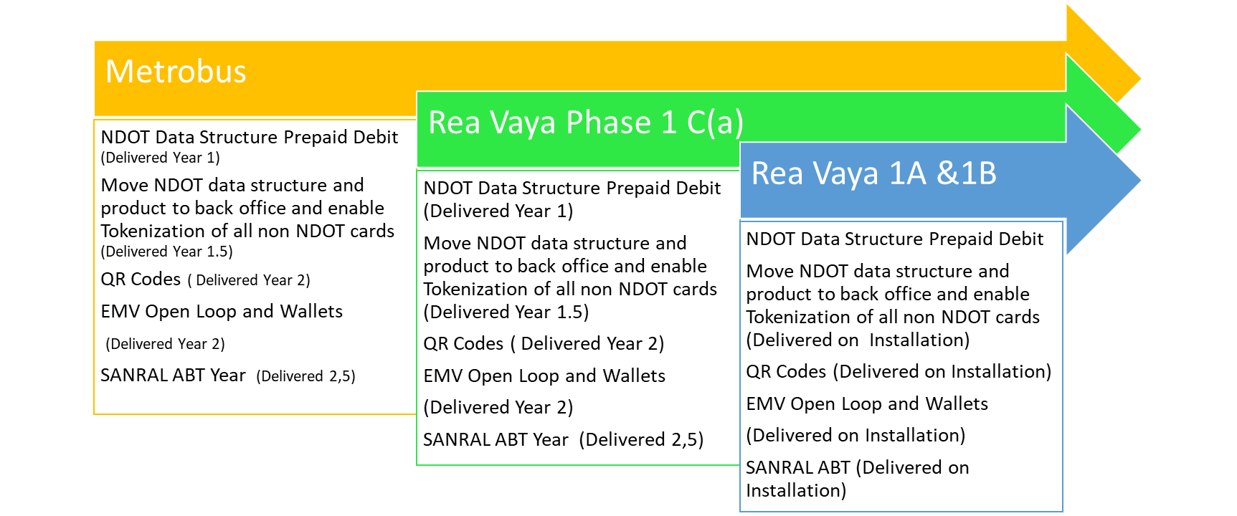

Bidders should give separate maintenance values for all different phases based on the their ability to install and implement different technology phases at different times and availability to implement on new stations and older phases

Bidders should take into cognisance the following:
Phase and Bus Operating Company | Availability
1C (a) excluding buses | Immediately
Metrobus | Immediately
Rea Vaya phase 1A and 1B (387 station gates and 195 buses) | March 2023

Part C3.5.3 Section Test Completion Deadlines
The following deadlines must be considered as to when the AFC System must be operational (provided in Table 7):

Table 7: Compulsory Test Completion Deadlines
Compulsory ISAT Description | Test Completion Deadline
Phase 1C(a) 17 Stations | 2022/04/01
Metrobus | 2022/05/01
Phase 1A & 1B | 2023/03/31
Other IRPTN Phases | 2023/06/30

The above dates are dependent on when actual award occurs

PART C3.6 STANDARD SPECIFICATIONS

The design, build, and maintain of the AFC System shall be according to the relevant Standard Specifications as can be found within Volume 2B – Part C5. These standard specifications are referenced in Table 8.
Table 8: Standard Specifications Register
Contract  Part | Name
C5.2 | COJ - AFC #15 - Non-Returnable - Vol 2B - Part C5.2 - Annexure A - AFC
C5.3 | COJ - AFC #16 - Non-Returnable - Vol 2B - Part C5.3 - Annexure B - SLA
C5.4 | COJ - AFC #17 - Non-Returnable - Vol 2B - Part C5.4 - Annexure C - ELECTRICAL
C5.5 | COJ - AFC #18 - Non-Returnable - Vol 2B - Part C5.5 - Annexure D - ELECTRONIC
C5.6 | COJ - AFC #19 - Non-Returnable - Vol 2B - Part C5.6 - Annexure E - Stipulated Minimum Local Production Thresholds
C5.7 | COJ - AFC #20 - Non-Returnable - Vol 2B - Part C5.7 - Annexure F - Rea Vaya Fare Policy
C5.7 | COJ - AFC #21 - Non-Returnable - Vol 2B - Part C5.7 - Annexure F – Metrobus Fare Policy
C5.8 | COJ - AFC #22 - Non-Returnable - Vol 2B - Part C5.8 - Annexure G - NDoT AFC Data Structure
C5.9 | COJ - AFC #23 - Non-Returnable - Vol 2B - Part C5.9 - Annexure H - ICT
C5.10 | COJ - AFC #24 - Non-Returnable - Vol 2B - Part C5.10 - Annexure I - VOIP
C5.11 | COJ - AFC #25 - Non-Returnable - Vol 2B - Part C5.11 - Annexure J - TCE
C5.14 | COJ - AFC #28 - Non-Returnable - Vol 2B - Part C5.14 - Annexure M - mSCOA Requirement
C5.15 | COJ- AFC#27 -Non Returnable - Vol 2B- Part C5.13 - Annexure N-14-f-mastercard-transit-solutions-guide
 | COJ - AFC #29 Returnable -Vol 2B - Annexure O Compliance Matrix

Part 3.7 Repairs and Maintenance

The Contractor shall be responsible for all costs associated with the repair and/or replacement of modules, parts and components removed from the equipment supplied under the Contract which have been found to be defective in terms of material, workmanship or function under the terms of the warranty.

The contractor warrants that all installation work and all System hardware and software furnished by the contractor including, but not limited to, all such work, and System hardware and software provided by sub-contractors, suppliers, or other manufacturers, shall be of good quality and free of any defects or faulty materials and workmanship for the ONE-YEAR warranty period.

The Contractor shall also warrant that all installation work and system hardware and software shall perform according to the specifications for the one-year warranty period. If the Proposer upgrades its devices to ensure the continued and proper operation of the System as configured for Project, the Proposer will assume all costs related to the hardware upgrade and there shall be no additional cost to the Commission.

Extended Service / Warranty Period The Commission requests that Contractor propose an extended service / maintenance agreement beyond the initial one-year period for a minimum period of an additional four years, priced annually (not including option years). The Proposer shall define all terms, conditions, and costs of the extended service / maintenance agreement in its Cost Proposal. Proposers should include any annual software fees and hardware service / maintenance escalation percentages.

